INTRODUCTION
Lesson 1

In the 1300's little or nothing was known about two thirds of the
Inhabited (lived in) world.
Most people lived in a world which had the Mediterranean Sea at its centre. Yet 300 years later the American Continent had been discovered, the world had been circumnavigated (travelled round) and less than a third of the world remained unknown.

At the end of this unit of history you will learn why and how these amazing feats were achieved.

You will learn about -
- People's ideas about the world in the Middle Ages (500AD -1500AD)
- Reasons why people explored the world
- Marco Polo and his voyages (travels)
- What life was like for an explorer
- Christopher Columbus and his voyages
- Ferdinand Magellan and his voyages
- What people had learned about other countries and cultures
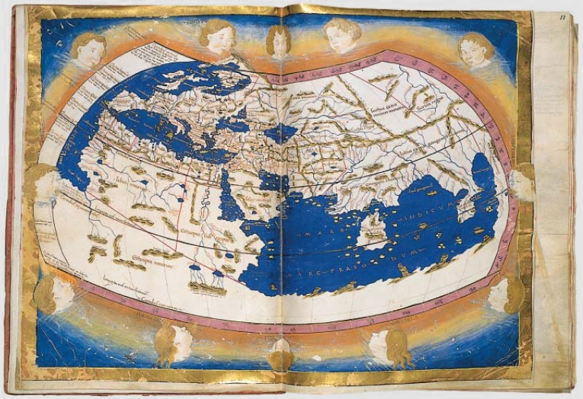
by the 16th century.

The World in the Middle Ages

- In the 1300 the people of Europe knew very little about the rest of the world. There were many reasons for this:
- Most people thought the world was flat
- No one from Europe ever sailed far from land
- People who discovered something useful often kept it to themselves!
- Maps were not accurate or scientific
- Religion was very important. Often churchmen, being the largest group of people who could write, also made maps. They tended to put Jerusalem (The Holy City) at the centre of the world!
- Maps were often based on rumours or guesses
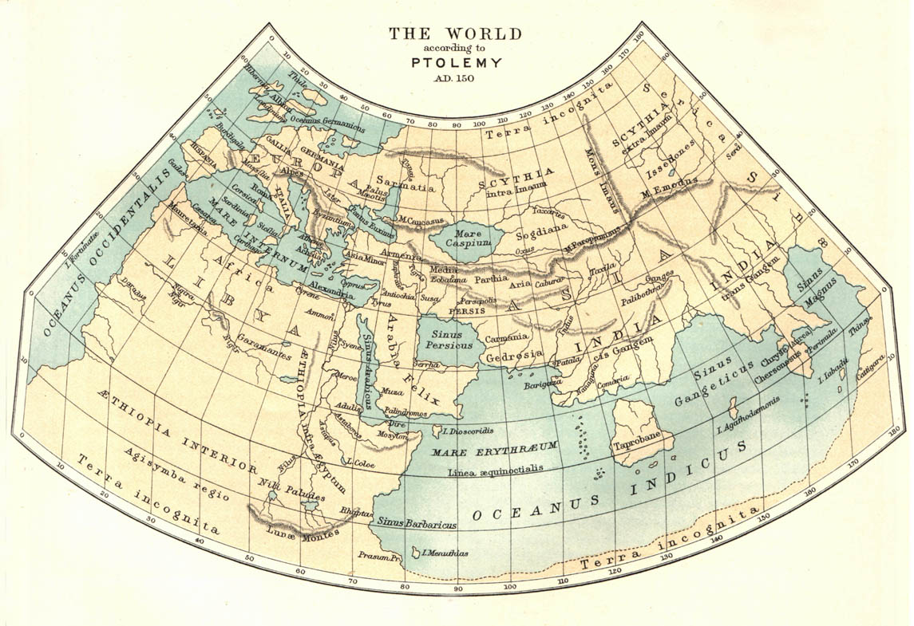
PTOLEMY’S MAP
This map of the world was made about 2,000 years ago

HEREFORD MAP
This map was made by an unknown English monk about 700 years ago

TASK

- Make a title page Voyage of Discovery
- Write the heading The World in the Middles Ages
- Answer the following questions in sentences:

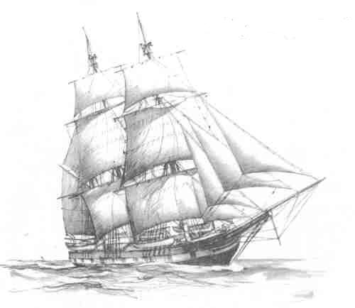

QUESTIONS

- Give 3 reasons why people in the Middle Ages knew little about their world.
- Which of the two maps on the previous page is the older? Say why you think so?
- Which map was made by the person who knew more about the shape of the world? Why do you think this?
- Look at map 2. Which continents are shown? Which are left out? Why do you think these continents have been left out?
- Looking at the maps, write a short paragraph explaining the differences between Ptolemy and Hereford’s ideas about the shape, size and continents of the world.

Myths and Legends
Lesson 2

Many people were afraid to travel in medieval times because of the stories told by travellers who had visited foreign lands. These stories were often exaggerated.
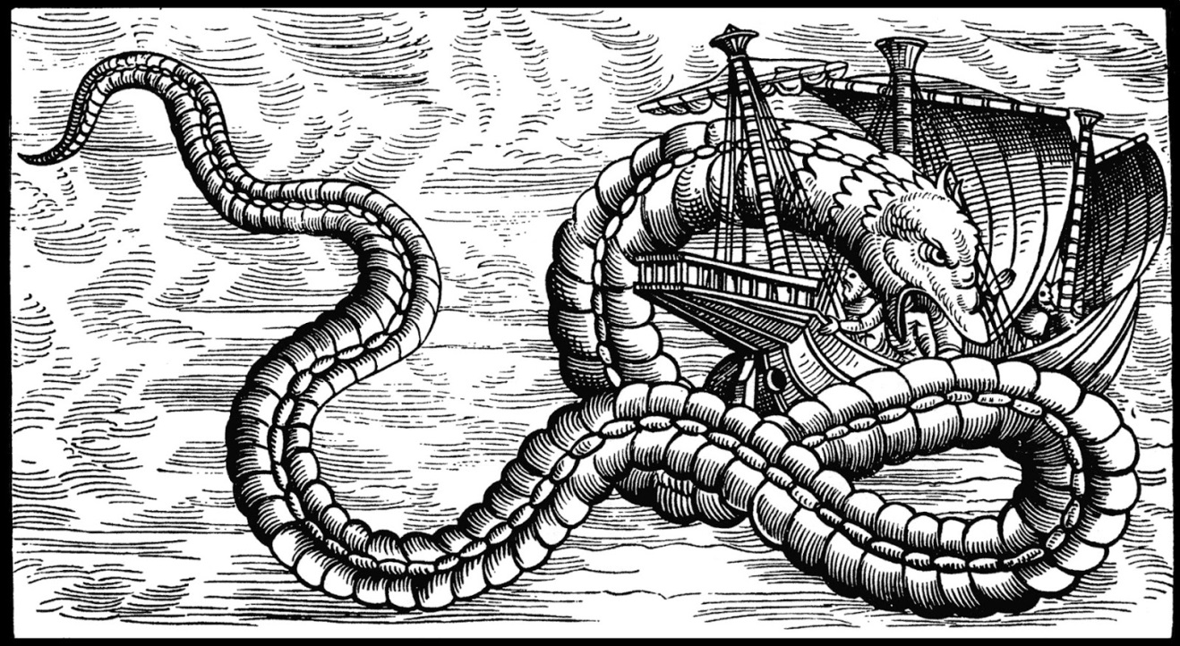

SOURCE 1 – An Arab Legend (a story passed down from person to person)
“Beyond Cape Bojador the sun grows hotter, the sea storms and becomes a thickening broth coated with a scum of green weed infested with monsters.
Near the equator the sea boils, the tar would boil in a ship’s seams and the brains in a man’s head.
There, in that area, huge sea serpents, which would crunch up ships like a biscuit.
Allah has placed the green sea as a barrier across the southern ocean.

SOURCE 2 – Pictures showing creatures that people believed lived near
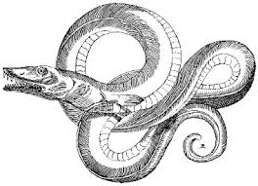
the “edge of the world”.
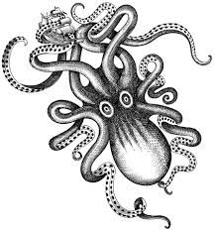
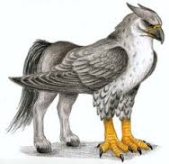

SOURCE 3 – A cartoon showing some reason why sailors in the 14th Century might be very reluctant to go on a long sea voyage.
Will I fall off the end of the world?
I’ve heard stories about monsters!
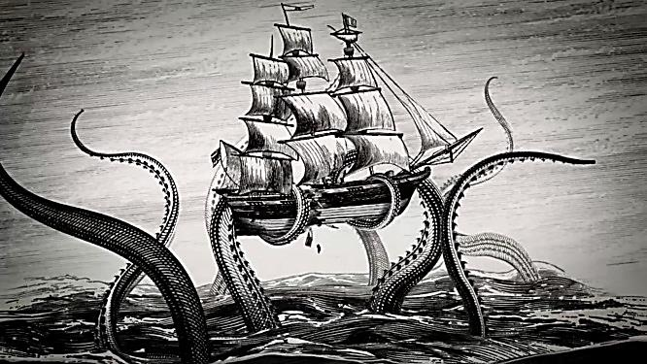
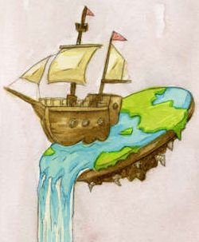

Natives might be unfriendly!
I will miss my family!
I might catch a disease!

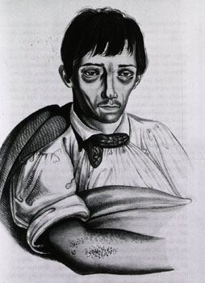
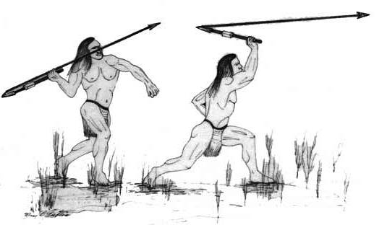

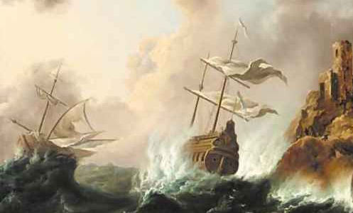
My ship might be wrecked!
What if I get thirsty or hungry?

TASK

- Write the heading Myths and Legends
- Look at Source 3. Some of these things frightening the sailors are actually quite reasonable, even in the 21st Century. Others seem ridiculous with the knowledge we have today.
- Put two columns in your jotter, like the example below and put all the reasons from Source 3 under one of the headings.
Sensible | Not sensible

- Answer the following questions in sentences:

QUESTIONS
- Legends often have a tiny element (part) of truth in them. How do you think the stories about sea-monsters might have started?
- Is Source 1 a primary or a secondary source for finding out what Arabs thought about the dangers at sea?
- According to Source 1, what were the main dangers of the sea?

REASONS FOR EXPLORATION
Lesson 3
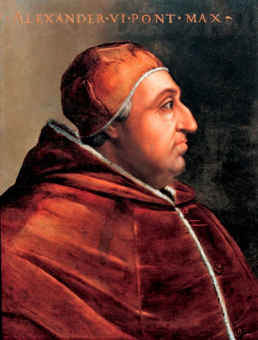
Religion
People were strongly religious and felt it was their duty to convert (change) the religion of strangers they met.
In 1493 Pope Alexander 6th split the undiscovered world into two parts. One part went to Spain the other to Portugal. Arabs were Muslim traders who controlled the land routes to the east.

Technology
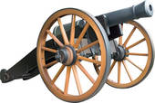
Ships were always improving. They were stronger and faster. Navigational instruments, maps and tables were becoming more accurate. Cannons, guns and the weapons being used at the time were better at protecting explorers from hostile (dangerous) enemies.

Ambition
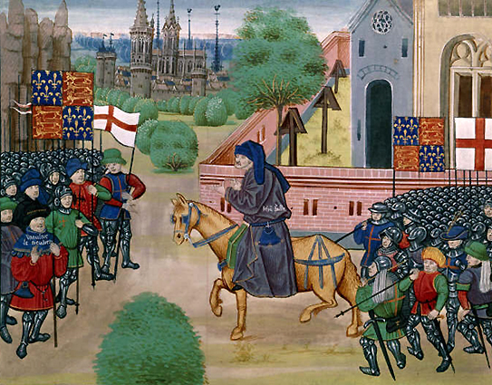
Many Captains saw a chance to become famous. Successful explorers were the equivalent to film or television stars today! Rulers saw a chance to increase their wealth and power.

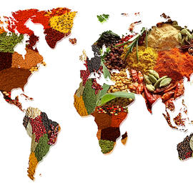
REASONS FOR EXPLORATION (continued)
Shortages in Europe/Treasures of the East
European food was traditionally plain and could even have been described as boring. Since there were no refrigerators foods went off very quickly. Meat was preserved in salt but this gave it an unpleasant taste. Spices were a perfect and tasty way of seasoning and disguising this. Spices came from the Far East by land.
- Pepper: The dried fruit of the pepper plant. It has a hot taste. Found in India and Southern Asia.

- Nutmeg: The strong smelling centre of the nut of the nutmeg tree. Found in East Indian Islands.

- Cloves: The dried flower bud of the clove tree. Has a strong taste. Found in the East Indian Islands.

- Ginger: The root of the ginger plant. Found in India.

- Cinnamon: The bark of a small tree. Found in India and Ceylon.

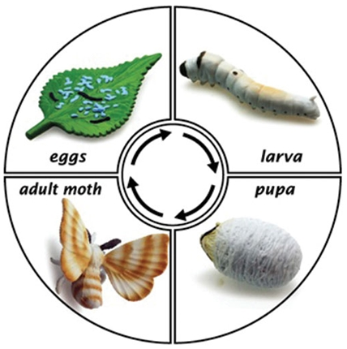
European clothes were also plain and silk became a sought after luxury. Laws like the “Sumptuary laws” were passed to actually stop ordinary people dressing in silk. Jewels, perfumes, drugs such as camphor and borax also came from the Far East.

TASK

- Write the heading - Reasons for Exploration

- Answer the following questions in sentences:

QUESTIONS
- Name the four reasons why people explored the unknown world.
- From these reasons, which do you think were the most important and explain why?
- For what reasons do you think people explore the “unknown” parts of the world today? Explain your answer giving at least two reasons.
- In the Middle Ages spices were considered to be luxury goods.
(a) Are spices still a luxury today? Explain your answer.
(b) What do you consider to be luxury today?

5. Unscramble the following words to find out some
more treasures of the East.

Kliss tgemun sgrud velcos weljes regign

TASK
- Look at the map below which was made in the year 1515.

- Answer the following questions in sentences:

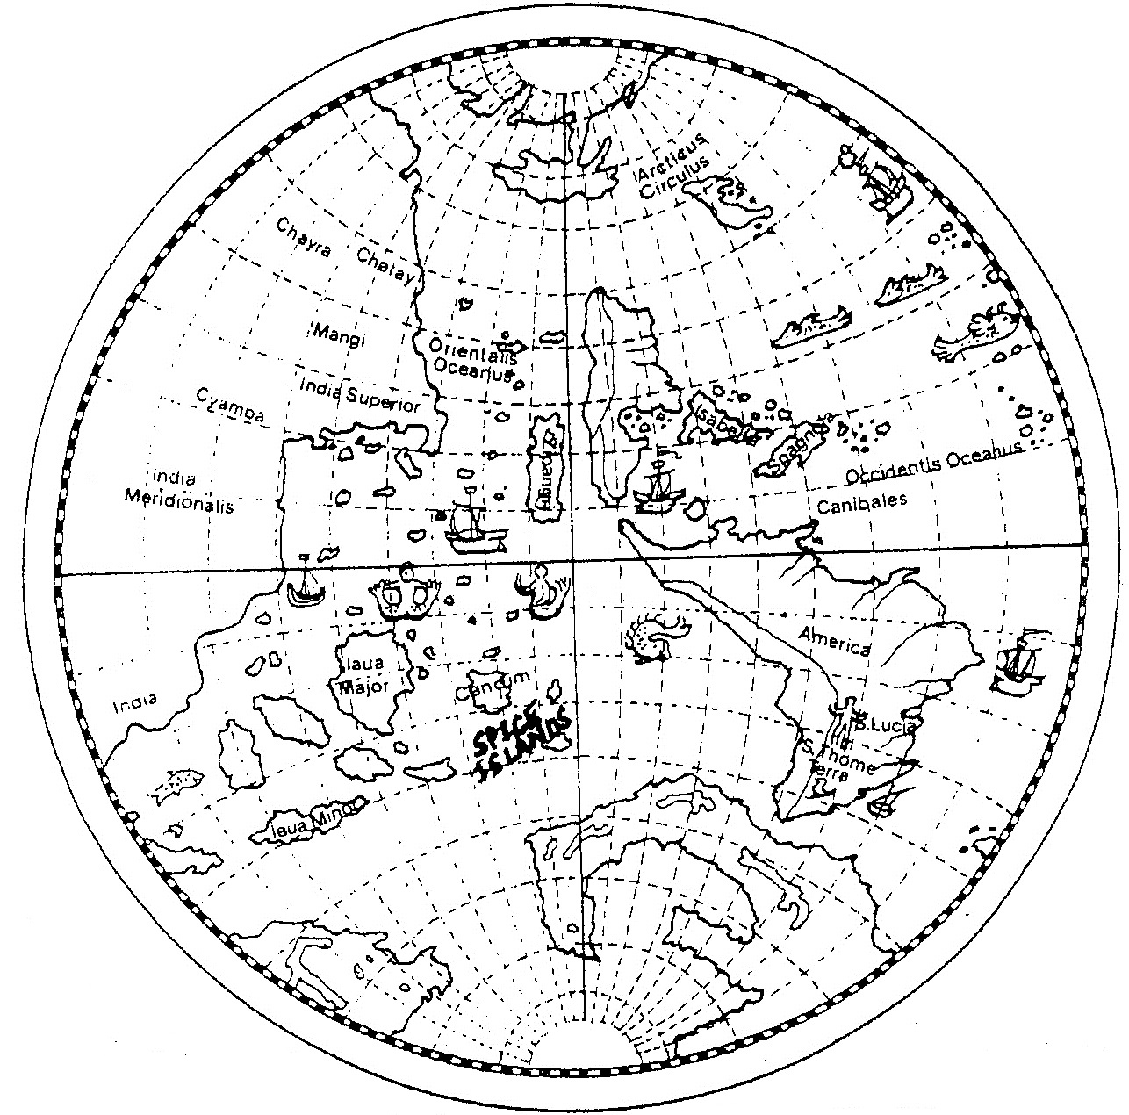

QUESTIONS
- Look at the map and list 3 countries we can recognise today.
- How does the map differ from a map of the world today?
- Why do you think the map is so different to our knowledge of the world today?
- What dangers does the map suggest sailors would face crossing the sea? Give evidence to support your answer.

Homework 1
IMAGINATIVE WRITING EXERCISE
Two sailors are having a talk about the dangers of a long distance voyage of discovery. Write out that conversation in the form of a script. Take a double page in your jotter and leave a border around the edge in which to include drawings of some of the dangers. Make this as colourful as you can, using lots of imagination!
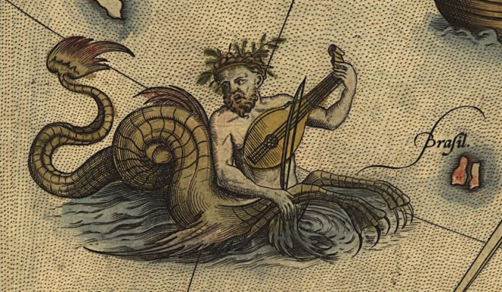
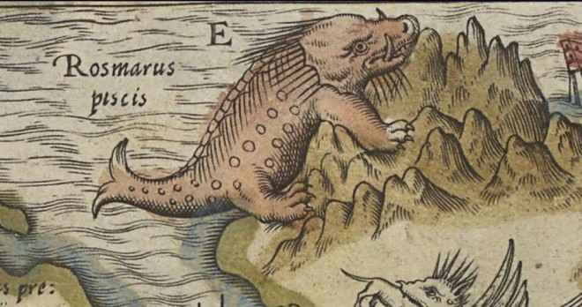
For example:

Archie: Well hello Fred. Where are you
off to?
Fred: Some fellow at the docks
asked me to go on a voyage….but
I am not sure.
Archie: I don’t think you would catch
me doing something like that!
Have you not heard……

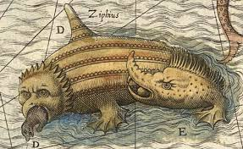
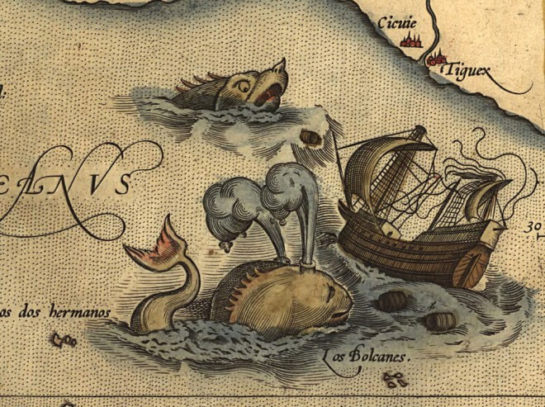

MARCO POLO AND THE SILK ROAD
Lesson 4
Silk could only be found in the Far East and Europeans had to travel there to buy this luxury. The road they took to the east became known as “Silk Road”
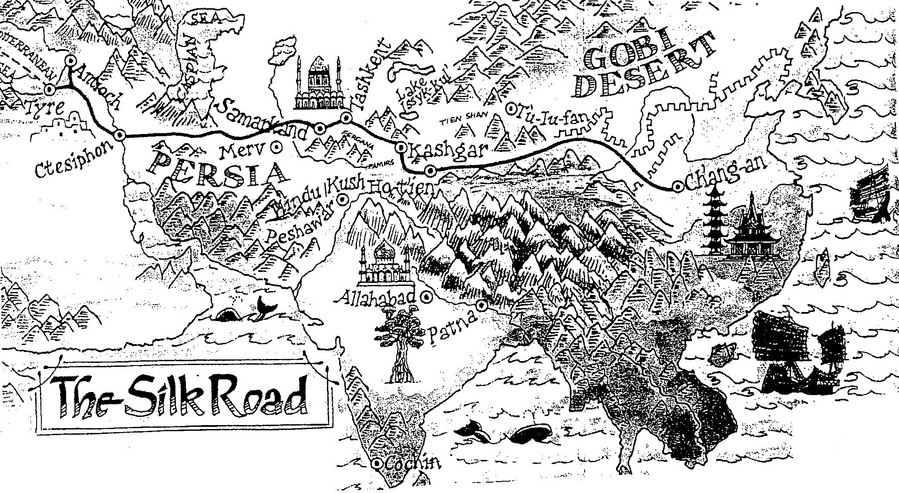

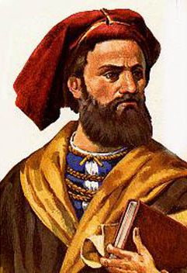
MARCO POLO (b.1254 – d. 1324)
In 1271 Marco Polo set out with his father, who was a merchant in Venice, across the ”Silk Road”, the overland route to China.
Marco’s route east took him through Arab controlled areas of the Mediterranean Sea where pirates would “rob everything on board”.
For safety they travelled in groups with other Christian merchants to give themselves protection against bandits and Arabs stealing their goods. However, they went further east than other Europeans and later had to travel on their own.
They crossed deserts where they saw visions that were really heat hazes and spirit voices that were the sound of the wind passing over the sand. They climbed mountains where the oxygen levels were so low fires would not burn in the biting cold winds.

SOURCE 5 & 6 - Two descriptions of Marco Polo’s journey
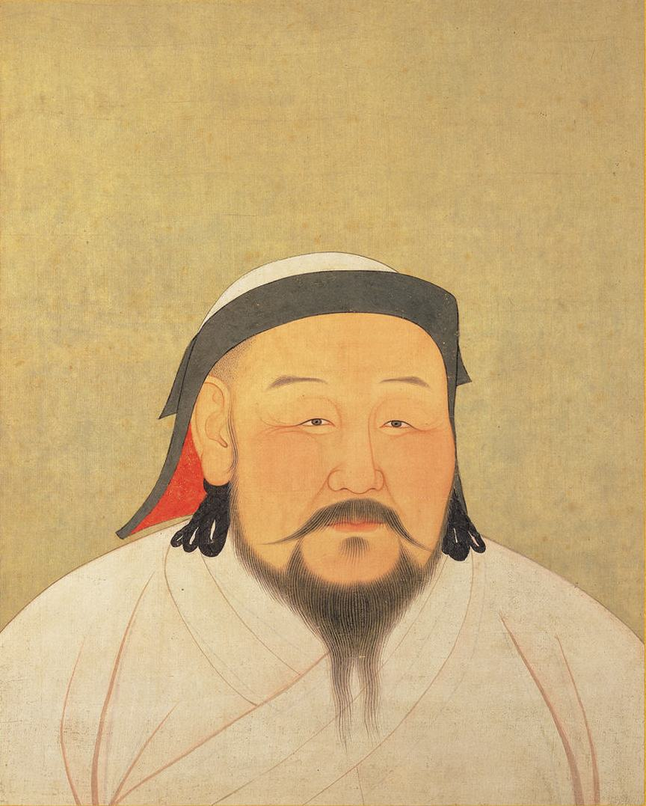
Source 6
About a desert
To cross this desert by the narrowest path takes a month. To travel the whole length takes a year. In this desert there are neither beasts nor birds, because there is no food for them.
Source 5
About a mountain range
Eventually the road leads to what you might think is the highest mountain in the world. Heaps of horns and bones are found at the side of the road, to guide travellers when the ground is covered in snow.

Kublai Khan

At last the Marco Polo arrived at the court of Kublai Khan where they were given gold tablets that acted as passports for the travellers. Everywhere they went they were now well treated. Marco Polo worked for Khan for 17 years and went further into Asia than any other European.
Marco Polo and his group arrived home to a “cool” welcome as people did not believe who the family were. Their travels had taken 24 years! Marco became a successful merchant and in 1299 published his description of the world. It became a medieval best seller and inspired other explorers like Christopher Columbus to try to reach the East.
TASK
- Write the heading Marco Polo and the Silk Road
- Copy a table like the one below and list the “areas” and dangers that Marco Polo might have faced.

Trip | Dangers
Mediterranean Sea
Arabs
Pamir Mountains
Gobi Desert
Long Overland Journey | Killed by unknown animals or diseases

- Answer the following questions in sentences:

QUESTIONS
- Whose court did Marco Polo arrive at and why was this very lucky for them?
- Is Source 5 a primary or secondary source of Marco Polo’s journey? Give a reason for your answer.
- Does Source 6 give detailed information about Marco Polo’s journey through the desert? Provide one quote from the source to support your answer.

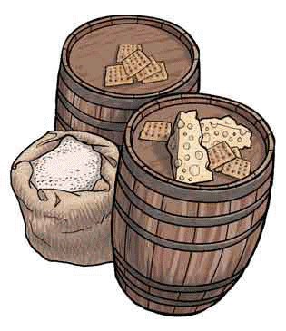
Lesson 5
LIFE AT SEA
Long voyages often involved being at sea for months, even years. Fresh food was unobtainable and even drinking water was scarce. Before the days of canning and refrigeration, storing food on board was a problem.

Fresh fruit and vegetables rotted quickly and meat was salted and stored in barrels. “Hard tack” was a type of biscuit that was kept for years. These biscuits often became infested with beetles and maggots which had to be removed before the biscuits could be eaten!

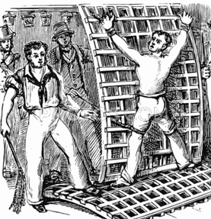
The most common punishment for sailors was the “cat-o-nine tails” – a whip with nine length of knotted leather cord attached to a handle. The sailor to be punished was tied to a frame and flogged on his bare back. The number of strokes would depend on the crime. Even a few strokes would inflict great pain and could draw blood. A doctor had to be in attendance to stop the flogging if it appeared the victim was in danger of dying.

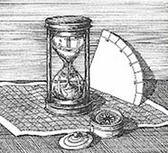
Before the invention of radio, radar or satellites, navigation involved manual calculations.
Navigators used instruments designed for observing the stars in the sky and what sea charts they had. They then could steer a straight course between two points taking wind direction, currents and rocks.

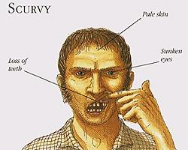

Terrible diseases in particular scurvy (Vitamin C deficiency) were very common resulting in many deaths at sea.

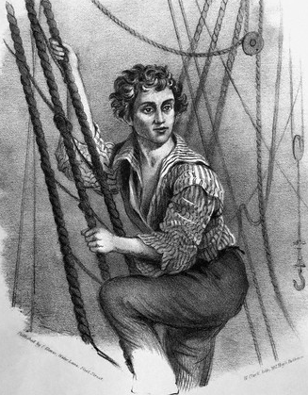

Sailors duties included climbing the high fasts and rigging to work with the sails (often in terrible weather) taking turns on watch and swabbing down the filthy decks.

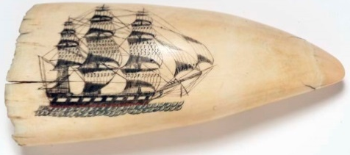

Seamen spent what time they did have to themselves playing games, hobbies and sometimes pranks on other crew members.

TASK
- Write the heading Life at Sea
- Create a table like the one below
- From the Source “Life at Sea” place the appropriate information under each heading
Food | Daily Duties
Navigating | Health
Past Times | Punishments

HEALTH AT SEA
Lesson 6

Source 1 – The Ship Surgeon
Ships surgeons varied widely in ability. They were important in battles when they had to amputate smashed arms and legs. Speed was vital because quick work reduced the risk of infection, which killed more men than the surgery.

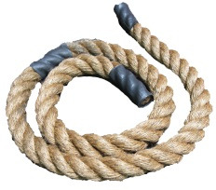
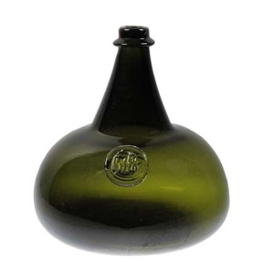
Source 2 – Some of the surgeon’s tools!
GAG – Patients were given a gag made of rope or leather to bite on as another way of coping with the pain. Mercifully, the patients usually fainted!

RUM – The surgeon’s patients were given rum to try to numb the pain, as amputations were done without anaesthetics.

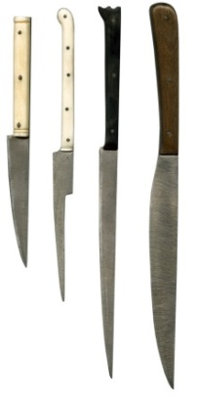
BONE SAW – Fine, sharp saws cut through leg and arm bones. They were standard tools in the surgeon’s kit.
KNIVES – Razor-sharp knives cut through skin, muscle and ligaments to reach bones.

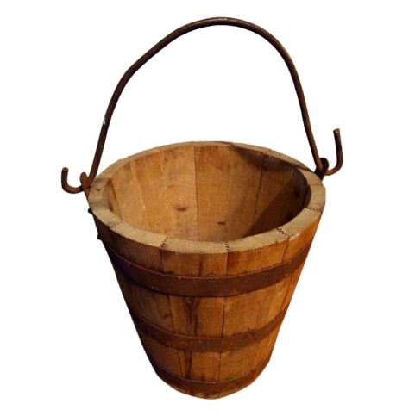
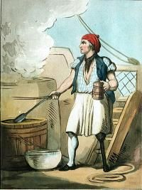
BOILING PITCH – After The amputation the bloody arm or leg stump was dipped in boiling (tar) to seal the wound
PEG LEG – The amputee was given a wooden leg so he could walk again.

TASK
- Imagine you are a surgeon on a voyage of discovery, after a lengthy battle the leg of a sailor has been severely damaged by a cannonball.
- Describe injuries and the treatment of the patient. You can illustrate your work with pictures of the tools used.

It had been a long and difficult battle…….

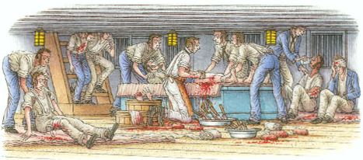

Homework 1

IMAGINATIVE WRITING EXERCISE
“Sailors in the fifteenth century were right to feel afraid”

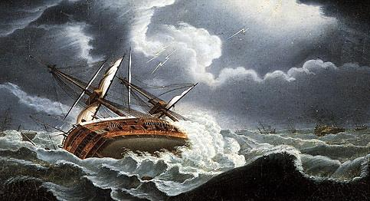

Do you agree with this statement?

Use the following headings to guide your answers which should be in paragraph form.

- In what ways were sailors right to feel afraid?
- In what was were sailors silly to be afraid?
- How would you feel?
- Overall, do you think they were right or wrong to feel afraid about going on voyages of discovery?

Lesson 7

CHRISTOPHER COLUMBUS 1451 – 1506
Born in Genoa, Italy, Columbus soon decided he wanted to go to sea. He had little formal education but by his teens he was sailing around the Mediterranean Sea. He showed a natural skill as a navigator.

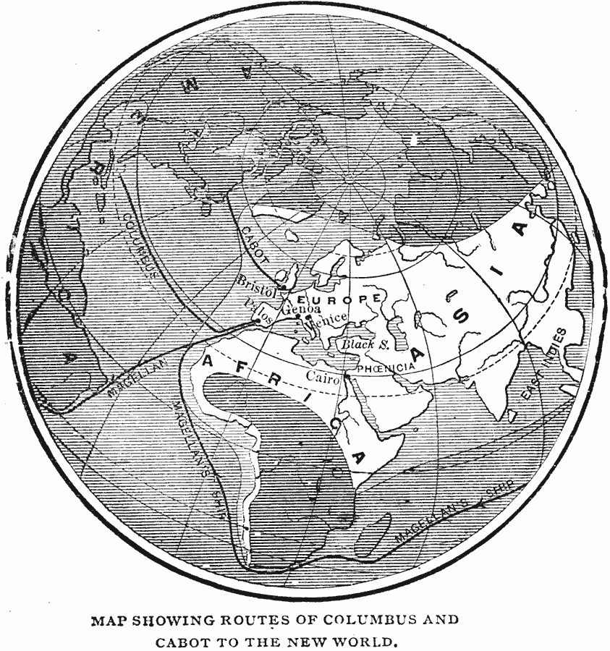
Columbus was one of the few men at the time who thought the world was not flat but round. Columbus was also one of the few men who believed it was possible to sail westwards and still get to the Spice Islands in the East!

Columbus was ambitious – his motto was “Gold,God and Cathay”. However, he was not a rich man and to test his theory he has to persuade rich people to buy ships and men to sail with him. No one was prepared to give Columbus money as they thought his idea was crazy!

Aged 25 a shipwreck brought Columbus to Portugal. Here he made and sold maps and lived amongst Europe’s most experienced sailors. He travelled to the Canary Islands, Madera, and West Africa.

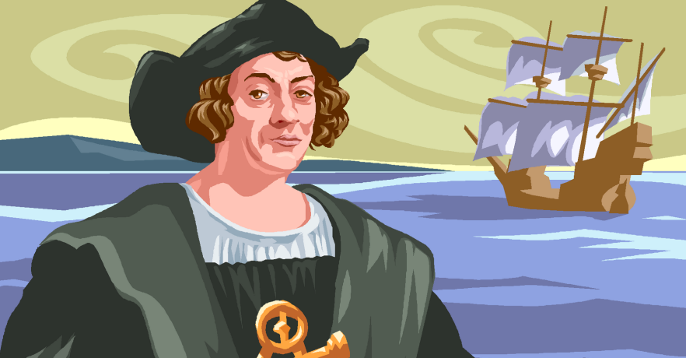

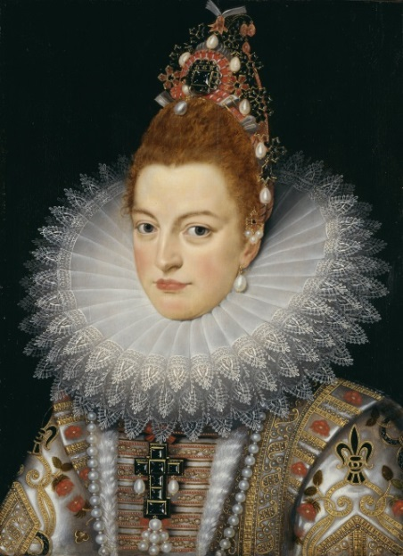
So Columbus went to Portugal’s rival Spain. It took Columbus 5 years to persuade Queen Isabella of Spain that his idea would work. In 1492 she agreed to give Columbus the money he needed.

TASK
- Write the heading Christopher Columbus in your jotter
- Answer the following questions in sentences in as much detail as possible.

QUESTIONS

- Read these statements and copy out the ones you think are true.
- In 1476 Columbus moved to Lisbon, the capital of Portugal and made maps.
- In 1476 Columbus moved to Paris, the Capital of France and made ships.
- Columbus was an experienced sailor and sailed to many places.
- Columbus did not know a lot about sailing.
- Columbus had read stories about Marco Polo and was interested in his travels.
- Columbus had read stories of Leonardo da Vinci’s travel’s and was scared.
- Lots of people offered money to help Columbus fund his voyages.
- Nobody would help Columbus fund his voyages until finally the Queen of Spain agreed to give him some.

- Imagine you are Christopher Columbus writing a letter to try and persuade the Queen of Spain to give you money to pay for your voyage. Your letter should include:

- What you want the money for.
- How experienced you are.
- Why you want to sail westwards.
- All the benefits the Queen can expect when you return!

Begin your letter…..“Your most Royal Majesty,
My name is Christopher Columbus……”

THE JOURNEYS OF CHRISTOPHER COLUMBUS

First Voyage
Columbus set sail in 1492 with 3 ships, the Santa Maria, the Nina and the Pinta. The islands he discovered became known as the “West Indies” – because he had sailed westwards to find them and thought they were India.
TASK
- Write the heading - Columbus’s first voyage in your jotter
- Copy the following:
1492 Columbus set sail from Spain with 3 ships the Santa Maria, the Nina and the Pinta. He discovered the West Indies.
- Listen to the tape and make rough notes in the back of your jotter.
- Answer the following questions in the front of your jotter using your own notes.

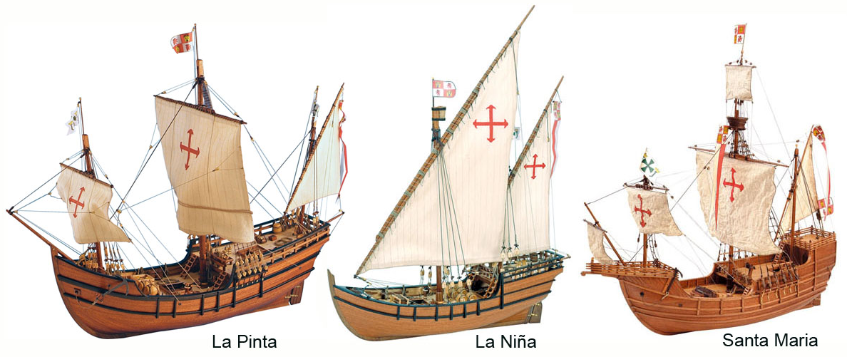

QUESTIONS
- What did Columbus soon find was his greatest difficulty?
- In total, how many men sailed with Columbus?
- What were taken as signs that land was near?
- What was the signal used by the 3 ships to indicate that land had been seen?
- What did Columbus “plant” on the beach of San Salvador?
- How long did the three ships search the islands for gold?
- What happened to the Santa Maria?
- And what was La Navidad?
- When did Columbus reach Palos, Spain when sailing on the Nina?

THE JOURNEYS OF CHRISTOPHER COLUMBUS

Eyewitness…
“I have come to believe this is a vast continent, previously unknown. I am led to this view by the Great River and fresh-water Sea. If this be a continent, it is a marvellous thing”
Christopher Columbus- Journal of his third voyage 1415 - August 1498

Columbus received a hero’s welcome on his return home and had no difficulty in raising money for his second voyage in 1493! This time he had 17 ships, 1200 men, horses, pigs and seeds.

On his second voyage Columbus again explored the West Indies. Again he found no significant wealth. He also became ill with fever and suffered temporary blindness. He returned to Spain a disappointed man.

Columbus sailed twice more to the West Indies. On his third voyage he discovered the mainland of South America.
In the last three years of his life Columbus tried to get money he felt was owed to him by King Ferdinand. He did not succeed and he died in 1506 worn out by his ling voyages. However he died not realising that he has never actually made the voyage all the way to Asia. It took Magellan to achieve this.

TASK
- Write the heading – Columbus’s last voyages
- Answer the following questions in sentences

QUESTIONS
- Read the extract from Columbus’s journal. Is it a primary or secondary source? Give reasons for your answer.
- Is it true he actually had discovered a continent?
- Complete the following sentences:
- On Columbus’s second voyage…

- On Columbus’s third voyage he…

- By his last voyage…

- When he died…

COLUMBUS - A HERO’S WELCOME
On returning from his voyages Columbus travelled overland to Barcelona where Queen Isabella and her husband Ferdinand gave him a hero’s welcome. Columbus returned with gold, parrots, animals, cotton, chillies, herbs, jewels and some local “Tainos” people he had taken prisoner.

An Italian called Christopher Columbus persuaded King Ferdinand and Queen Isabella of Spain to pay for an expedition to find China by sailing west instead of east. He set off in 1492 with three ships.
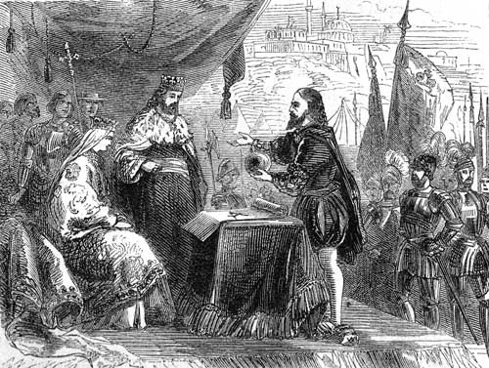

Columbus was richly rewarded with titles, money and was made a noble “Admiral of the Ocean Sea, Viceroy and Governor of the Islands”. Columbus had the right to rule some of the lands he discovered.
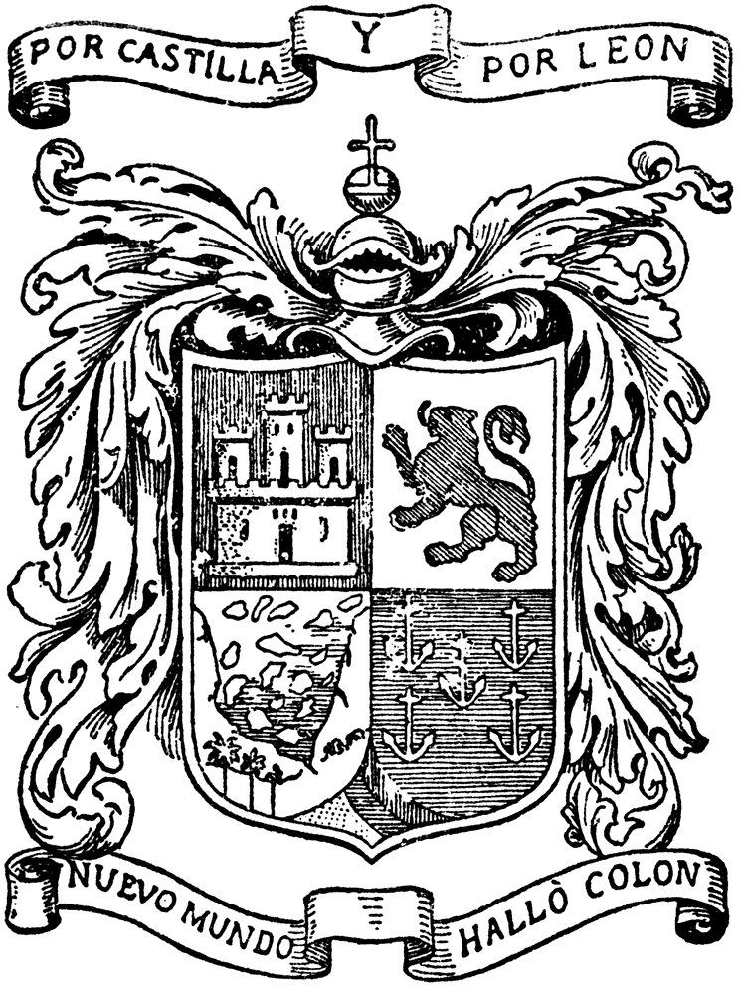

TASK
- Write the heading – Columbus’s Welcome
- Answer the following questions in sentences

QUESTIONS
- Why did Columbus receive a hero’s welcome?
- Explain why Columbus would capture natives, enslave them against their will and then bring them back to Spain?
- Look at the coat of arms. Each section describes an aspect of Columbus’s life. Design your own coat of arms with pictures illustrating:
- Your name
- Your hobbies
- Your ambitions
- Your family
- Where you live etc.

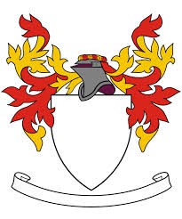

Lesson 8
FERDINAND MAGELLAN AND THE
CIRCUMNAVIGATION OF THE WORLD
Magellan believed he could reach the Moluccas by sailing west round the tip of America. Charles the 5th of Spain agreed to finance the scheme.
The Spanish wanted to establish trade routes to the East and claim territory there, Especially the Moluccas (Spice Islands)
Magellan left Spain in September 1519 with 260 men aboard 5 ships. They carried with them plenty of trading goods.

Yet Magellan encountered many problems. The weather was so bad he had to land for the winter and some of his men rebelled due to the terrible conditions. He had to suppress mutiny by executing the leaders. One of his ships, the Santiago was also wrecked.
The fleet crossed the Atlantic then sailed to Brazil then down the east coast of South America
Magellan underestimated the length of the voyage and didn’t take enough food and supplies.

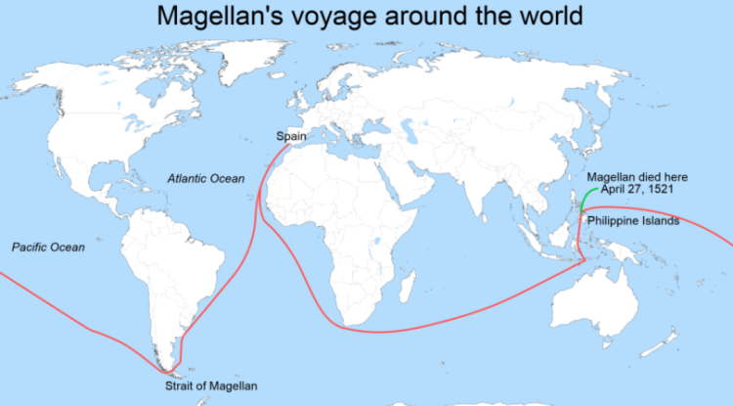
The other ships sailed on and reached Moluccas in November 1521 bringing back the spices they has set out for.
The ships took different routes back to Spain to improve the chances of getting some of the cargo home. The Trinidad went east but was seized by the Portuguese.
After stopping at the Marshall Islands Magellan continued on to the Philippines. Magellan became involved in a quarrel between two local chiefs. He and 40 of his men were killed.
A captain called Sebastian Del Cano took command of the 115 survivors. Without enough men he was forced to abandon one ship - the Conception.
Conditions got even worse for the crew. The San Antonio’s crew deserted, sailing away with most of the fleet’s food. 20 men on the other ships starved to death as they crossed the Pacific
The crew saw fires the natives lit so named the area “Tierra del Fuego” (land of fire). This discovery was vital since it proved Magellan that there was another way to the East, to the south of America.
‘S
The remaining ships found a route through the Pacific through a narrow sea passage now called the Straits of Magellan
The Vittoria went west. It crossed Portuguese trade routes in the Indian Ocean and rounded the southern cape of Africa. It managed to avoid capture and reach Spain in 1522 having sailed round the globe in three years.
TASK
- Write the heading – Ferdinand Magellan and the Circumnavigation of the World
- Copy and complete the fact-file below so that you have details of Magellan’s journey.

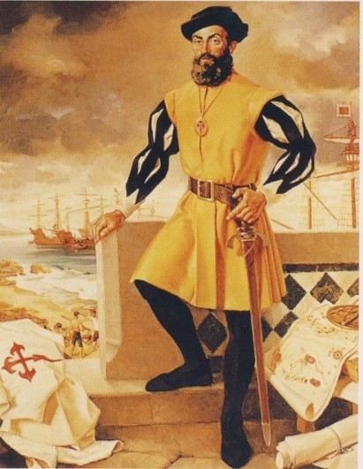
- Year the voyage began
- Number of ships
- Number of crew
- Who paid the wages
- First ocean crossed
- Second ocean crossed
- Place of Magellan’s death
- Name of the ship which made it back

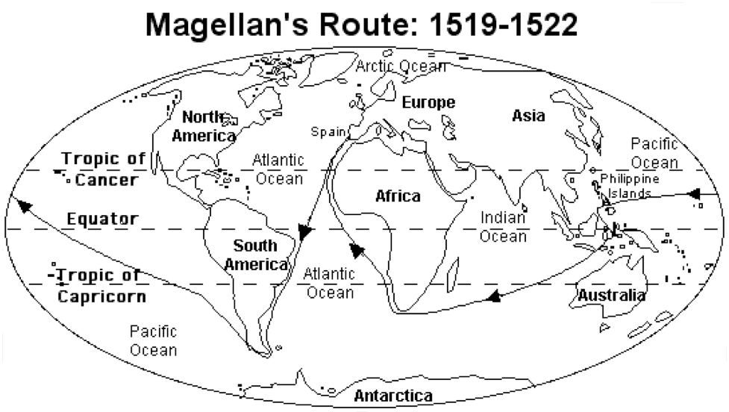

The discovery of the huge Pacific Ocean dashed all hope of opening up an easy westward sea route to the Indies. The ships of the day were too small and too slow to cover such distances on regular trading voyages. However by the 17th Century huge Spanish galleons went from Panama in Central America to the Philippines. The Philippine islands that Magellan discovered before he died became one of Spain’s most important colonies in the Pacific and remained so for 350 years.
QUESTIONS

- After Magellan’s voyage how did people’s knowledge of the world change? You should be able to find 2 changes.
- How many people died on the voyage?
- Who benefited the most from the voyage?
- In this section you have been learning about Magellan and his voyage, but there are lots of other interesting things you may like to find out about this famous journey (the first to prove the world was round).
Think of three things you would like to know more about and
write these in your jotter.

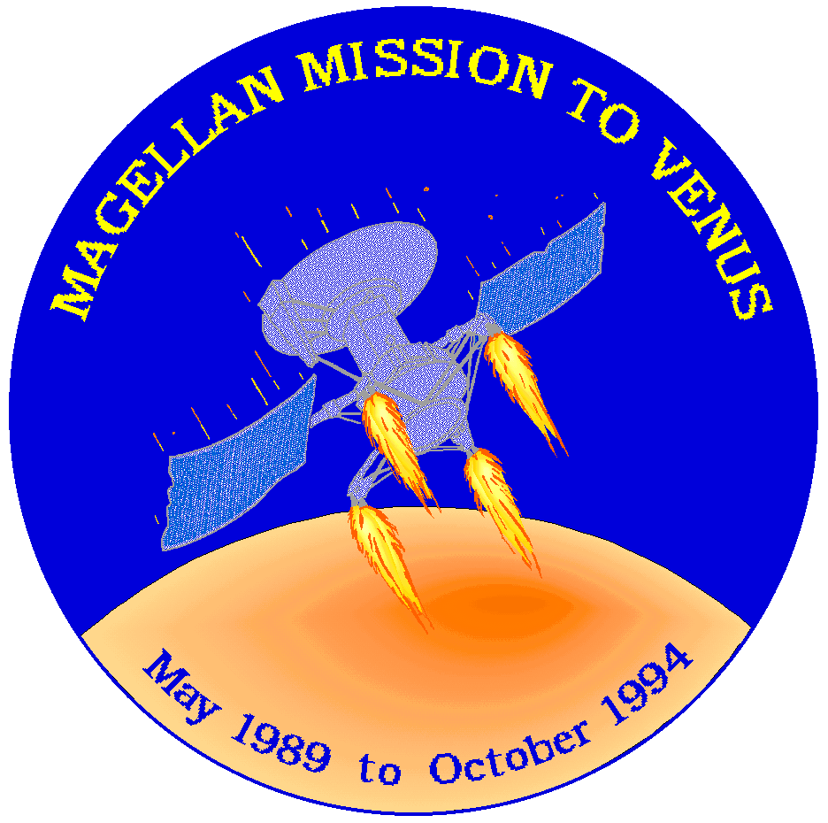
Who was the next captain to circumnavigate the world? This was an Englishman, Sir Francis Drake – 55 years after Magellan.
NASA wanted a name for the spacecraft it sent to circumnavigate the planet Venus for 4 years

Homework 3
PRINCE HENRY THE NAVIGATOR
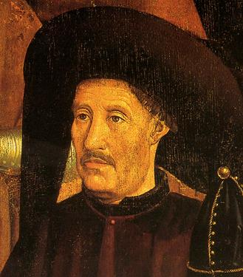
In the 15th century a young Portuguese Prince called Henry became convinced that there was a way ships could reach India to trade. He knew if someone from Portugal could discover a route it would become a rich and powerful country.

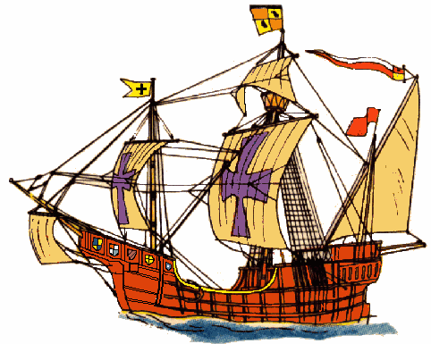

Prince Henry tried to train sailors in a naval school and taught them about ships, sailing, navigation and the seas. He collected the best navigators, map-makers and ship builders from all over Europe.

His hard work paid off and soon new ships called caravels were sailing on voyages down the west coast of Africa and into the wide Atlantic Ocean.
Source A is written by the captain of one of Henry’s ships when he visited Senegal and Gambia (West Africa).

Prince Henry of Portugal (1394-1460) Know as the Navigator
Portuguese Caravel
These sturdy but nimble ships borrowed some of their design from Arab boats called Dhows

Source A
“All of the coast is low and covered in very tall trees. In the market they trade by exchanging goods, they do not have money.
There are wild beasts- lions and leopards also elephants, giraffes and colourful birds – quite different from our own.
From The Sea Log of a ship Captain visiting Senegal and Gambia

- Who wrote Source A?
- Is Source A Primary or Secondary Source?
- Pick out 2 pieces of information from Source A which tell us that the countries visited by Henry’s ships were very different from their homeland.
- Using a map, why was Portugal in a good position to explore the Atlantic Sea and the coast of Africa?

Lesson 9

WHO BENEFITED FROM THE VOYAGES OF DISCOVERY?
The voyages gave people a more accurate picture of the world. People now knew the world was round and larger than they thought!
Navigational instruments and charts were now more accurate, making further exploration easier.
Weird and wonderful plants, fruits, animals and birds for example; sweet corn, tobacco and turkeys were discovered.
Source B
Examples of “discoveries from voyages given in a modern text book.
Source A
An animal drawn from the description of an explorer.

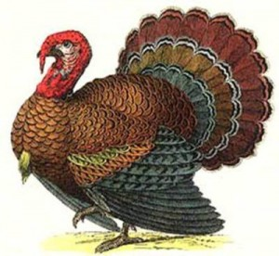
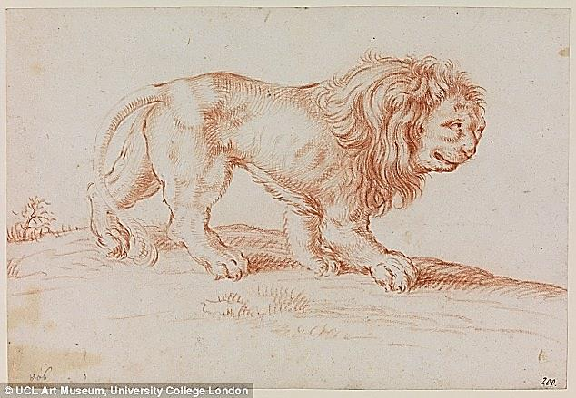

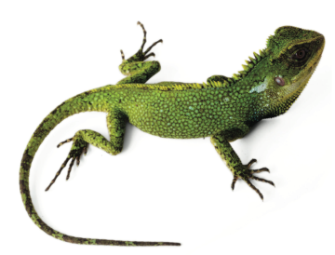

Captains/Explorers
- Marco Polo did not return from his travels rich but made money after he returned
- Christopher Columbus died aged 55 in disgrace.
- Magellan was killed by natives on the island of Mactan.
- Sir Francis Drake died of dysentery at sea and in disgrace.
Source C - words of an explorer:
“We Spanish suffer from disease that only gold will cure”

Sailors
- Died of awful painful diseases like scurvy
- Died far away from home
- Often not paid
- Magellan’s voyage – 280 men went, 31 returned
- Vasco Gama’s voyage – 148 men went, 55 returned.

Source D - words of a sailor:
“The crew dreaded the fire in lightning flashes, the air in its fury, the water from the waves and the earth for reefs and rocks”

Natives of the lands discovered
Source E - From “Christopher Columbus” published in 2001:
- 1492 – 100 million Native Americans.
- By 1600 – European diseases had killed 90 million of them, the worst disaster in history.

In 1495 Columbus sent 500 “Tainos” (a local West Indian tribe) slaves back to Spain – only 200 made the journey. This was the start of native inhabitants from discovered lands being sent to Europe as slaves. By 1450 – 1500 around 150,000 African slaves were bought by the Portuguese from African chiefs and sold in Lisbon.
Kings, Queens and Rulers
Arabs still controlled the land routes to the East. However Spain and Portugal were able to use the sea routes and set up colonies under their control in the American and African continents. Both Spain and Portugal became very wealthy and powerful countries. They raced to become the richest trading nation in the world. Spices, slaves, gold and silks provided immense wealth.
Source F – From “The Voyages of Christopher Columbus”, published in 1991.
Map showing the areas that within the 50 years of the death of Columbus the Spanish and Portuguese now controlled

TASK
- Write the heading – Who benefited from the Voyages of Discovery
- Read sources A – F and answer the following questions in sentences.

QUESTIONS
- Look at Sources A- F and state if they are a primary or secondary source and explain your choice. For example your answers should begin…. Source A is a secondary source because it is taken from second hand knowledge as the artist has not seen the animal.
- Copy the table below and decide if they benefited or not. Put your reason under the right column.
People | Benefited | Did not benefit
Natives
Sailors
Captains & Explorers
Rulers

- Using the sources and information you have already, writes an essay on the benefits of Voyages of Discovery. Use the following plan
Introduction: Little was known in 1300 about the world. Most people thought it was flat! However all this changed thanks to the voyages of Discovery. Now people knew the world was…..
Paragraph 1: Some people did benefit from the voyages as…..
Paragraph 2: People you did not benefit were….
Conclusion: By 1600 people’s knowledge of the world……You should include your view on whether more or less was gained from these voyages and why.

Complete the log below using your knowledge of the voyages of discovery.
Explain where you went, the journey, natives you met, your return voyage.
Lesson 10
Captain’s Log
I have been commissioned by his Majesty to command an expedition to sail to search for the City of Gold.
I am to bring back part of the fabulous wealth. My tree ships also have the task of mapping and exploring the lands to the west.
On ………………. We set out. A great crown of people cheered us from the harbour as we set off.

