S1
History Unit
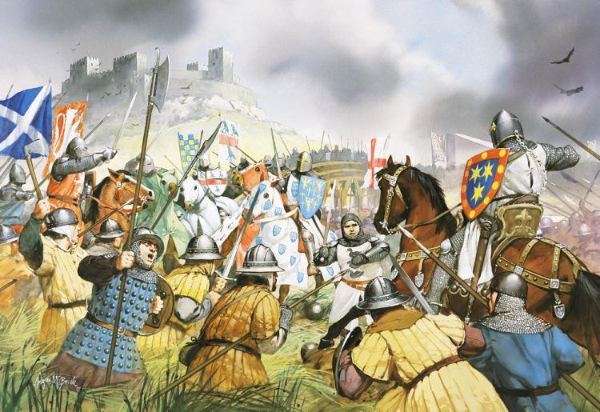

Scottish Wars
Of
Independence
Introduction
The death of King Alexander lll of Scotland in 1286 brought an end to a “Golden Age” in Scotland’s history. Soon Scotland was fighting with her powerful neighbour England. For a time she was an occupied country, governed by the English.
In this first unit we will follow the struggle led firstly by William Wallace and then by Robert the Bruce, to secure Scotland’s independence from England.
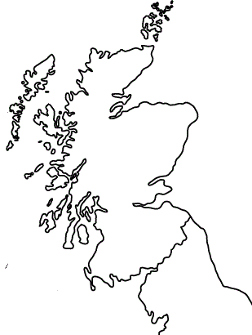

Inverness

Aberdeen
SCOTLAND

Arbroath

Scone
Perth

Dunbar
Stirling
Bannockburn
Edinburgh
Falkirk
Berwick Upon Tweed
Glasgow

Roxburgh

Newcastle upon Tyne
Map of Scotland and England showing place names mentioned in the text

Carlisle

ENGLAND

The Death of Alexander III
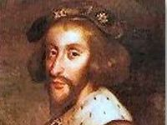
Alexander III became King of Scotland in 1240, when he was only 8 years old. He was a wise King and during his reign Scotland enjoyed many years of peace. However he suffered great personal unhappiness. His first wife Margaret and his younger son David died. Then his only daughter Margaret who was married to King Eric of Norway, and his heir Prince Alexander also died. This left Alexander III with no children.
In 1285 Alexander married again. His second wife was a French Lady called Yolande. People hoped that the King would have more children but on 18th March 1286 Alexander died tragically.

Death of a King - This play tells of the death of Alexander III

Characters:
- Alexander III
- Comyn
- Fife
- Alexander-Master of the King’s kitchen
- Wishart- Bishop of Glasgow
- Ferryman
- 3 Squires
- Servant

Scene 1
The main hall of the King’s castle in Edinburgh. It is Monday 18th march 1286.

King That was the longest meeting I’ve ever known. State business takes up so much time these days.
Comyn Aye, my lord. I think we are all tired out.
Fife Take a look outside my lord. Did you ever see such a storm?
King Aye my lord Fife. The storm has been raging all day. I could hear the wind battering against the castle walls all through the council meeting.
Comyn Now it is dark and the rain has turned to snow. It must be freezing outside.
Fife (Shivering) I’m glad I’m not travelling tonight.
Enter servant
Servant Dinner is served my lord.
King Come on my lords! Be of good cheer! Let’s forget about meetings and weather. There’s plenty of food and drink and a great fire to keep us warm!

Scene 2
The King and all his Barons are at dinner. Robert Wishart, Bishop of Glasgow rises.
Wishart My lords! Let us toast the King.
All The King! The King! To a long and happy reign!
King Thank you my lords. It pleases me that there are so many loyal men in Scotland, but now I must take my leave of you all.
Fife But sire! Have you seen the weather outside? Surely you do not intend to travel on a night like this?
King Unfortunately I must. I have promised to meet my wife Queen Yolande. Her Majesty is staying in Kinghorn.
Fife But that is 20 miles away my lord! Such a journey would be very dangerous in this weather. The roads will be very muddy surely you cannot cross the Firth of Forth in this gale?
King No my lords my mind is made up, I shall go tonight.
Fife Farewell and a safe journey sire.
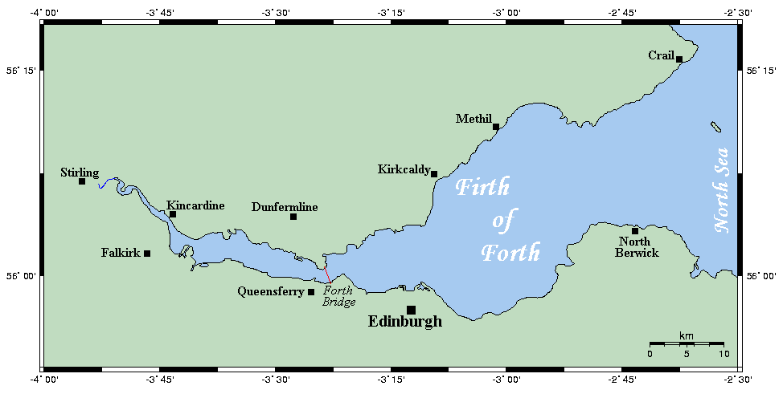
Comyn Take care my lord.

Scene 3
The King has reached Dalmeny on the Firth of Fourth.
Enter King and Ferryman.
King My good man I want to hire your boat to get to the other side of the forth.
Ferryman On a night like this? You must be mad? Who are you?
King Do you not know me? I am your King
Ferryman Forgive me my lord. But are you sure that it is wise to make such a trip across the Firth? And on such a night?

King Are you afraid to take the King?
Ferryman No my lord, it is an honour. Let us put our lives in God’s hands.
The trip is rough but they reach the other side safely

Scene 4
The seashore at Inverkeithing.
Enter King, 3 squires and Alexander, Master of the King’s kitchen.

Alex Welcome to Inverkeithing my lord. It is a wild night for travelling. Can I offer you and your servants a bed for the night?
King It is indeed a wild night. Thank you for the offer of a bed , but I must reach Kinghorn as soon as possible. Her majesty will be anxious.
Alex But sire it is madness to set off on such a night. It is dark and listen to that wind! Besides, the cliffs on the road to Kinghorn are very dangerous.
King Thank you for the warning but I must go. Farewell to you.
Alex Farewell my lord – and good luck!
The King sets off with his three squires along the rocky road to Kinghorn.

Scene 5
On the way to Kinghorn

Squire 1 I cannot see the path!
Squire 2 I cannot even see my horse, sire! We must return to Inverkeithing!
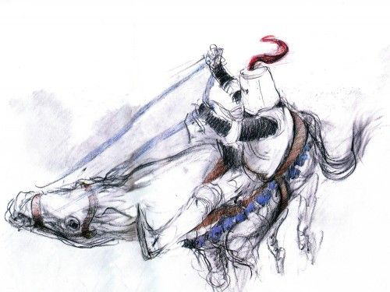
King We have not far to go my lords. Be of good cheer. Her majesty is awaiting our arrival.
Squire 3 My lord! My lord ! Where are you?
King AARGH!!!
Squire 1 My lord! My lord!
Squire 2 Oh alas! The King is dead.

Questions
- Write down the heading “Death of Alexander III” and copy down the following passage, filling in the blanks.

On the 18th March 1286, King Alexander left his castle in _______________ to go to see the Queen who was staying at ______________ . The weather was very ____________ . The King reached Dalmeny and crossed the Forth of Forth by ferry. He reached Inverkeithing and then set off on ________________ . It was very late at night and the road to Kinghorn was very ______________ . The King’s horse stumbled and Alexander fell off and tragically died.

- Write a newspaper article from the Edinburgh Times “ of 19th March 1286”
Take a blank copy of the cover of the newspaper , make up your own headline and begin your article with….
“Today the whole country is stunned by the news of the tragic death of our beloved King Alexander III…..”

The Edinburgh
Times
19th March 1286
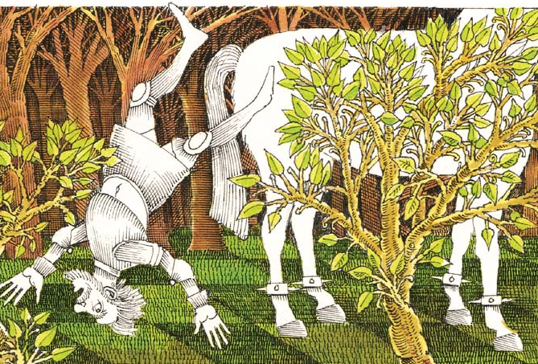
Today the whole country is stunned by the news of the tragic death of our beloved King Alexander III

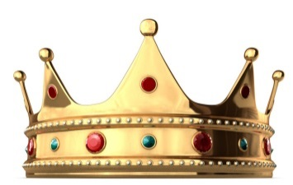
The Disputed Succession

?
The Maid of Norway
Alexander III’s daughter died before him so when Alexander fell to his death at Kinghorn, the heir to the throne of Scotland was his granddaughter Margaret The maid of Norway.
She was then only three years old and a sickly child. It was therefore decided that six guardians should be appointed to rule Scotland until Margaret was old enough to rule by herself. In 1290 Margaret set sail for Scotland but during the rough voyage she took ill and died on Orkney. Her body was taken to back Norway for burial.
The Disputed Succession
The death of Margaret, The Maid of Norway brought a further disaster to Scotland. No one could agree who would succeed her. Thirteen people called Competitors came forward to claim the throne of Scotland. They all thought that they had the right to be the next king of Scotland.
The two strongest claims were those of John Balliol and Robert Bruce, Earl of Annandale. Their names are underlined on the family tree below.
Scottish Royal Family
David I

Henry

Malcom IV William the Lyon David, Earl of Huntington

Alexander II Margaret Isabella Ada

Alexander III Devorgilla Robert Bruce Henry

Margaret Erik of Norway John Balliol John Hastings

Margaret the Maid of Norway

The Claim of John Balliol
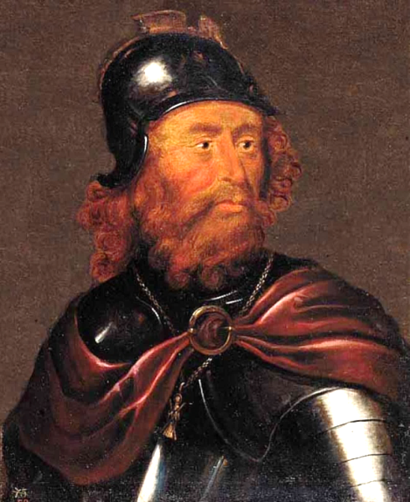
My Lords, my claim to the throne rests on one highly important fact. I am descended from Earl David’s eldest daughter… As we all know, the practice of Kings has been to give the crown to their eldest child. The family tree proves without doubt that I am descended from David’s eldest daughter, Margaret.
The Claim of Robert Bruce
My Lords, my claim to the Scottish crown rests on two very important points. In the first place, when Alexander ll lay in bed very ill and in danger of his life, he promised me that I would succeed him as King after his death.
My second point is no less important. The family tree clearly shows that I am the son of one of Earl David’s daughters, while my rival is only a grandson of one of Earl David’s daughters. Clearly then, I am a nearer relative to Earl David than John Balliol.

Discussion
Who do you think was the rightful heir to the throne? Give reason for your choice.

Edward’s Choice
The Guardians feared that fighting might break out among the 13 competitors and their supporters. One of the Guardians, the Bishop of St Andrews wrote to King Edward of England.

“The Kingdom (Scotland) is disturbed …. There is fear of general war and great slaughter unless your Majesty acts quickly.”

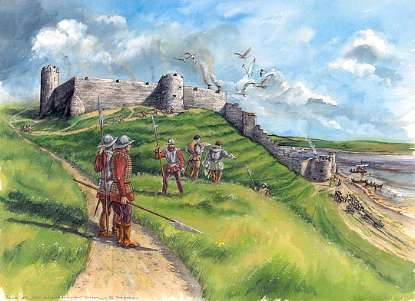
Edward was then invited to judge which of the 13 competitors had the best claim to the throne of Scotland. This was not unusual, Edward was Alexander’s brother-in-law, he was an experienced ruler and he was famous for his knowledge of the law. He had already acted as judge between two people who claimed the throne of Spain.

In 1291 Edward came to Berwick castle. He insisted that whoever was chosen as King of Scotland must agree to accept him as overlord. This meant that the new Scottish king would have to swear to be loyal to Edward and do whatever Edward told him.

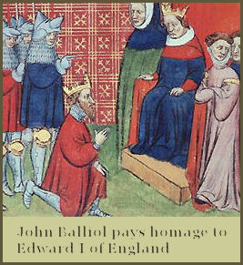
All the competitors agreed to do this as they did not want to spoil their chances of becoming King.
In 1292 Edward chose John Balliol as King. Balliol was forced to swear an oath of loyalty to Edward. Edward intended him to be only a puppet King.

Work To Do

Answer the following under the heading
The Disputed Succession.

Section A
- Copy down and complete the paragraph below by filling in the blanks.

After the death of ……………………the maid of Norway, ……………………….people claimed the throne of Scotland. King………………….of England was asked to judge who had the ……………………claim to the throne. He chose…………………..

- Do you agree with Edward’s choice? Give a reason for your answer.

Section B
Complete the following sentence:

- Edward was asked to decide who had the best claim to the throne of Scotland because….. (Give at least two points)

- Edward hoped that John Balliol would be a “puppet king”. What do yoy think this means? Why do you think Edward wanted Balliol as a puppet?

Further Reading
Pages 34 – 37 of “A History of Scotland Book 2”

Edward l’s Conquest of Scotland

The Auld Alliance
John Balliol was crowned on the 30th November 1292 at Scone. He reigned for four miserable years. King Edward ordered Balliol around as if he was an English noble not the King of Scotland.
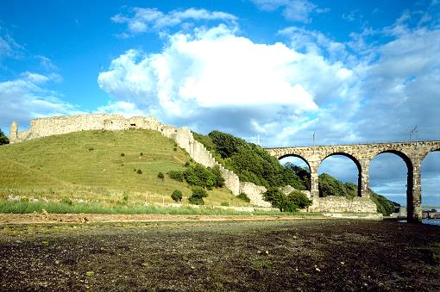
The Scots became angry and resentful. The last straw was when Edward l ordered the Scots to provide men and money to help him fight the French. Under pressure from his nobles Balliol refused and instead made a treaty (an agreement to help each other) with the King of France. This was called the AULD ALLIANCE. It lasted from 1295-1560.

The Siege of Berwick.
Berwick was a city right on the border with England.
The garrison was under the command of William Douglas.
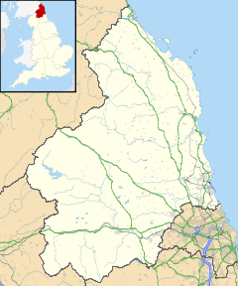

Part of walls of Berwick Castle and Royal Border Bridge

Berwick-upon-Tweed shown within Northumberland

Border in 1296

Source A
From ‘A history of Scotland – Book Two’ by William Moffat. Published in 1984. (The date makes this a secondary source since it was written after the events.)
It (the Auld Alliance) caused Edward to turn his full fury on Scotland. He marched north and entered Scotland at Coldstream on the 28th March 1296 and two days later seized Berwick, burning and killing without mercy

The English took the city brutally. As many as 10,000 men, women and children were killed. Evan a woman giving birth was hacked to pieces during her labour. This was witnessed by a relative of King Edward and it was this incident that finally brought the slaughter to an end. The English took Berwick Castle. Douglas surrendered and his life was spared.

Source B
Here is a primary source (a source written at the actual time of the events) by an Englishman.

Berwick was occupied by the enemy. Much booty was seized and no fewer than 15,000 of both sexes punished, some by sword, others by fire. The survivors, including even little children were sent into exile (sent out of the country) forever. But this most merciful King Edward showed mercy to the dead as well as the living. I myself saw a huge number of men sent to bury the bodies of the fallen. They were to receive as wages a penny each, at the King’s expense.

Booty – goods which have been plundered or stolen
Merciful – showing kindness, usually towards someone who has done you wrong.

Work to do
Copy the heading ‘Edward 1’s Conquest of Scotland’

- Copy and complete the following paragraph.

Balliol finally rebelled against Edward’s unreasonable demands when Edward demanded ……………………and ………………….to fight the ……………….. Balliol refused and made a treaty with ………………… This was called the……………….. …………………. This was an agreement to ………………..each other against the ………………………. Edward was furious when he heard and planned to teach the Scots a lesson. Edward first attacked the Scottish town of ……………………….. About …………………… scots were said to have died in a particularly brutal attack.

- Copy and complete the following sentences.

- Source A is a secondary source about the siege of Berwick which means it was written ………………………………
- Source B is a primary source about the siege of Berwick which means it was
written ……………………………..

- Find a phrase in Source B which shows that the writer was an eyewitness to
what happened.

- How does the writer of Source B describe King Edward’s behaviour at Berwick?

- How does the writer of Source A describe the way the people of Berwick were treated by the English?

- Which source do you think was closest to the truth? Name the source and pick 2 reasons from the list below.

- The writer of Source B was there at Berwick and was an unbiased witness.
- The writer of Source B was English and therefore a bit biased (one-sided) in favour of his King.
- The writer of Source A was writing a long time after these events and was less likely to take sides.
- The writer of Source A wasn’t there and doesn’t know the facts.

The Capture of John Balliol.

After laying siege to Berwick, Edward led his army further into Scotland. He defeated the Scots easily wherever he went. In July 1296, King John Balliol surrendered to Edward at Kincardine Castle. He handed over his country and his people to Edward. The crown was ripped from John Balliol’s head, the royal sceptre dragged from his grasp and the ring pulled from his finger. The royal emblem (badge), the Red Lion of Scotland, was ripped from his surcoat or tabard. After that, Balliol was known as “Toom Tabard” meaning “empty jacket” or “King Nobody”. He was then taken as a prisoner to the Tower of London.

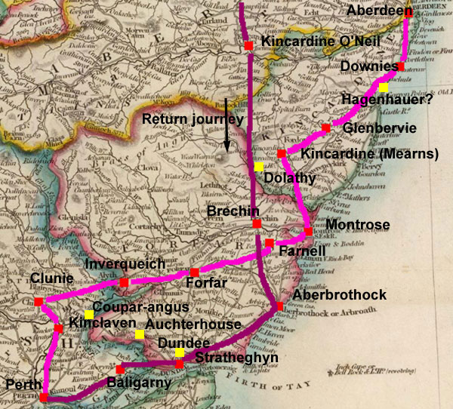
Edward I’s route throughout Scotland

King Edward seized the ancient Stone of Destiny on which Scottish Kings were crowned, and placed it in Westminster Abbey in London. He also took the Scottish Crown Jewels. An Englishman, De Warenne the Earl of Surrey, was appointed Governor of Scotland and Hugh Cressingham was made Treasurer Scottish castles were garrisoned by English troops. Scotland was now a province of England.

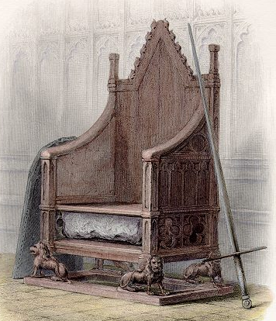
The Ragman roll
All over Scotland, Edward forced important people such as noblemen, barons and Bishops, to swear an oath of loyalty to him. Two thousand names were collected together on 35 sheets of parchment which were then sewn together. Because of the ragged tangle of ribbons hanging from the wax seals, it became known as the “Ragman Roll”.

Edward had humbled the pride of the Scottish people. The Scots now shared a common hatred of the English and a determination to free Scotland from English control. The Scottish Wars of Independence. Scotland’s fight to be free of English control, now began.

Work To Do
Continue under the heading ‘Capture of John Balliol’
- Copy down and complete:
In 1296, John Balliol surrendered to Edward 1 at ……………………. ……………………….. The ……………………… ………………………was ripped from his tabard, and after that he was known as ………………………….which means …………………… ……………………..Balliol was imprisoned in the Tower of…………………….. DeWarenne the Earl of …………………… became Governor of Scotland, and ……………………..was appointed treasurer. Edward seized the Stone of ……………………… and the Scottish ……………………… …………………………

2. a) Who were forced to sign the “Ragman Roll”?
b) What promise did they make by signing?
3. What effect did Edward I’s actions have on the Scottish people?
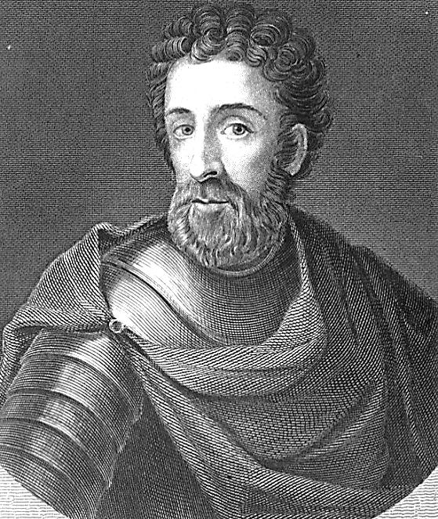
William Wallace
Among those determined to push the English out of Scotland was William Wallace, the younger son of a knight from Elderslie in Renfrewshire. Wallace seems to have been a warlike man of great strength and perhaps with a quick temper. Along with his brother he refused to sign the Ragman Roll, and submit to the English.

In May 1297, William Wallace quarrelled with some soldiers in the market place at Lanark. A fight began and an English soldier was killed. A girl helped Wallace to escape. Some people think she was his wife, but we do not know for sure. The girl was caught and put to death by the Sheriff Lanark, William Hazelrig. In revenge, Wallace returned to Lanark with a small band of men and killed the Sheriff. The rest of the English soldiers were forced to leave Lanark.

By the end of 1297, Wallace and his men attacked the town of Scone. In Scone there was an English judge called William Ormsby. He was punishing those people who would not swear to be loyal to King Edward of England. Ormsby escaped from Scone and rode to Edinburgh to tell the English soldiers about Wallace’s attack.

The news of these events spread quickly throughout Scotland. Wallace’s band of soldiers became an army. After a failure to defeat the English at Irvine, with the help of Robert Bruce, Wallace fled with his supporters to Selkirk Forest. But while Bruce made peace with the English, Wallace continued the struggle.

Meanwhile, in the north of Scotland, another landowner’s son, Andrew Murray, was fighting the English. He managed to capture some important castles from the English soldiers. Eventually William Wallace and Andrew Murray met at Perth. Their followers elected them “leaders of the army of the Kingdom of Scotland”. Murray and Wallace soon heard that an English army was marching north. They decided to go to Stirling and wait for the English army there.

Who was William Wallace?
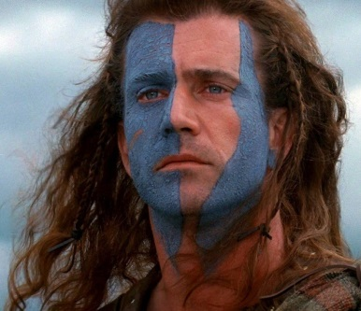
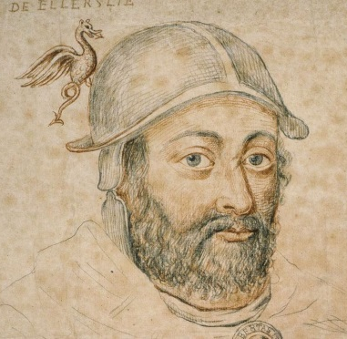

Separating the Fact from the Legend

When we study an historical event on a person from history it is very important to separate the Facts from the Legend.

Facts – A thing that is known to be true about a person or an event.

Legend – Information or stories about a person or an event which many believe to be true but are not certain to be true.

In groups of four you are going to carry out some research into William Wallace. You will use the internet for this research. You will try to find:
- As many facts as you can about William Wallace.
- As many stories or bits of information about William Wallace which are legends.
Tips
- To start with, google “William Wallace”
- Look carefully at the results of this search to find the best sites.
- You might want to split your group into pairs. One pair can be “Factfinders” and the other pair can look for legends.

You have one period for your research. You will then have a period to put your research into a report titled “Wallace – Facts & Legends”.
Be prepared to present your research to the class.

The Battle of Stirling Bridge 1297

The greatest triumph for William Wallace was the defeat of the English army at Stirling Bridge in 1297.

On September 11th, the Scots led by William Wallace and Andrew Murray, took up position at the foot of the Ochil hills. They were inexperienced fighters who were used to raids and skirmishes. They had never fought a pitched battle. They had few cavalry. Most of the Scots army were foot soldiers, armed with daggers and with 12 foot long spears. They were determined to free Scotland from the domination of the English.

The English army was drawn up on the southern end on a very narrow wooden bridge which crossed the River Forth near Stirling. It was a very large army, with many experienced warriors who had fought in France and Wales. They had many knights, and behind them, row upon row of spearmen.

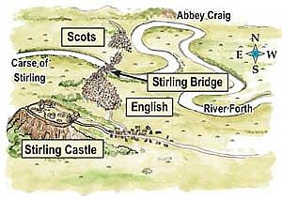
Map of the Battle

Work to Do
Under the heading The Battle of Stirling Bridge 1297, answer the following

- Copy the map opposite, showing where the battle took place.
- Draw a table

Scot’s Advantages | English Advantages

Put the following points in the appropriate column of the table:

A good leader Reinforcements in Stirling Castle
Experienced in fighting Determination
Determination Many knights on horseback
A large army
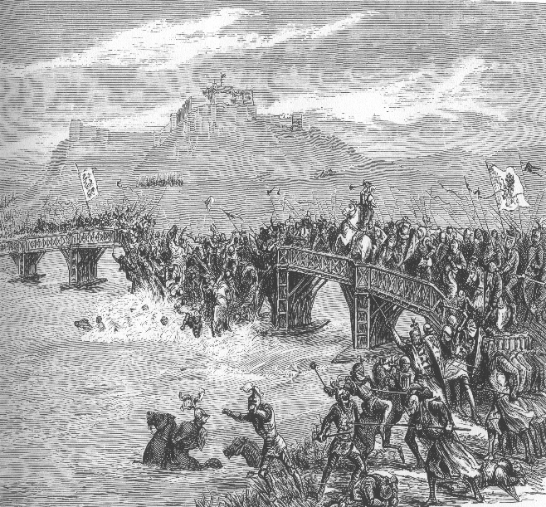
The Course of the Battle
On September 11th 1297, the English began to cross the bridge. It was so narrow they had to cross it in twos. A good number of the English had crossed the bridge and were jostling for position on the soft carse or meadow land, when Wallace sounded his horn and the Scots charged. Their right wing swung round and cut the English off from the bridge.

The rest charged into the body of the English army, spearmen against knights.
Soon there was confusion in the English ranks. Horses reared and stumbled and their riders were thrown onto the soft carse. The Scottish spearmen lunged in among the helpless mass. In a panic, some of the English knights tried to ford the river, but their armour weighed them down too much. On the bridge itself, those retreating in disorder were trapped by the others still trying to cross. Men and horses plunged to their death in the swirling waters of the river Forth.

Soon was all over. The English were scattered or slain. The Earl of Surrey had fled. The Scots wandered across the battlefield, collecting booty from the fallen knights. From among the dead, the body of the hated Cressingham was picked out. In savage revenge, the victorious Scots flayed it and took away strips of his skin as souvenirs of Stirling Bridge.

During the next few months the Scots were able to recapture man of the castles from the English control. Scottish raiders laid waste to farms and abbeys in the north of England.

In November however, Andrew Murray died, probably from wounds he received at Stirling Bridge. This was a great loss to Wallace, but he carried on the fight against the English.

In March, 1298 Wallace was appointed Guardian of Scotland and became known as “Sir” William Wallace.

Work to do
Work in small groups.
Write the script of a news report for Scottish television about the battle of Stirling Bridge.
Each member of the group should take part and write his/her own part of the script.
Suggested roles: studio presenter, reporter on the battlefield; William Wallace; a soldier who took part (either Scottish of English).
Present your news item to the rest of the class. The script should include:-
- Events of the battle
- The fate of Hugh Cressingham
- Whether you think Andrew Murray might die of his wounds
- Who will now lead Scotland
- Possible next moves of the Scots
- Probable reaction of King Edward

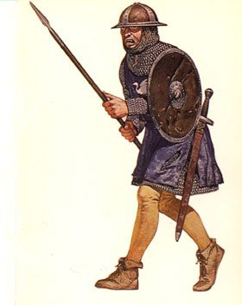
The Battle of Falkirk

Edward 1 could not forget the defeat of his army at Stirling Bridge. He was determined to get his revenge on the Scots. So in the north of England he collected together a huge army of 2,000 knights and 12,000 footsoldiers including a large force of crossbowmen and archers from Wales. These archers were tall, strong men who could fire a 6 foot longbow accurately over 250 yards.

Once again the Scots army was smaller than the English one. It was mainly made up of spearmen. There were very few knights and only a handful of bowmen. The scots halted near Falkirk on July 22nd to wait for the English army and prepare for battle. They were in good spirits after their recent success at Stirling Bridge.

The English army on the other hand was in poor shape. They did not have enough food and many of the men were sick. Some of the soldiers had mutinied (refused to obey orders). King Edward himself was in great pain as a result of a kick from his horse.

William Wallace drew up his army on a hillside. Behind the Scots was a rough woodland, and in front of them was a small loch and a strip of march. Wallace ordered his men to build a barrier of wooden stakes in front of this. Behind the barrier, he formed his spearmen into 4 schiltrons. These were circular groups of men with their spears pointing outwards. Wallace placed groups of bowmen between the schiltrons. The Scottish knights were right at the back.

Work To Do
Answer the following, under the heading The Battle of Falkirk, 1298
1. Here is a list of facts about the situation before the battle began:
- The scots army had drawn up on a hillside
- The Scots army was smaller than the English army
- The English army was tired and short of supplies
- Behind the Scots army was rough woodland
- In front of the Scots army was a marshy ground and a small loch
- The Scots had very few knights
- The Scots army was behind a barrier of wooden stakes

Put these points into the appropriate column of the table below

Good Points for Scots Army | Bad Points for Scots Army

MAP OF THE BATTLEFIELD

The Battle
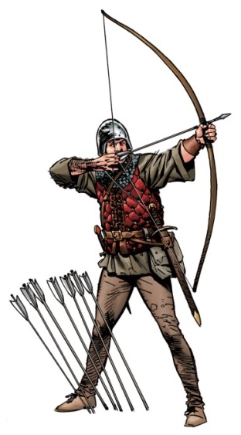
When the battle began, the English knights split into two halves and made their way round either side of the small loch. They approached the Scots from behind. The Scottish knights fled, leaving the bowmen helpless. The bowmen were soon cut down. The English knights charged the schiltrons but could not break through. King Edward then brought up his Welsh bowmen. They calmly fired arrow after arrow into the schiltrons until the rings of spears were opened by lanes of dead or dying. Next time the English knights charged, the schiltrons could not hold. The English had won the battle. Edward had got his revenge for the defeat of Stirling Bridge.

William Wallace escaped from the battlefield. He resigned his post as Guardian and fled abroad. Over the next ten years Edward slowly regained control of Scotland. Wallace travelled through Europe trying to get help from a foreign country against the English. Eventually, in 1305 he returned to Scotland alone.

Work To Do
Section A
- On your copy of the map of the battlefield.show
- Label the following:
Marsh, woodland, loch, wooden stakes, Scottish knights, schiltrons, bowmen
- Show with arrows, the attack by the English knights.
- Explain the meaning of “schiltrons” using a diagram if you wish.
- Read the information and study the pictures in A History of Scotland Book 2, pages 50-51. Imagine you are William Wallace. It is the night after the battle, and you are writing up your diary. How did you feel before the battle against the English – confident? Worried?
What went wrong during the battle.
- With your knights?
- With your bowmen?
- With your schiltrons?
How did you escape from the battlefield?
How do you feel now?
- Where did Wallace go after the battle and why?
- When did Wallace return to Scotland?

The Capture, Trial and Execution of William Wallace

After his defeat at the battle of Falkirk, Wallace fled to Europe, and tried to get help against the English. He was not successful and in 1305 he returned to Scotland alone. This play is about what happened to him then

Characters: Narrator, William Wallace, Sir John Stewart, Servant, King Edward, 5 Judges, First Man, Second Man, Woman 1, Woman 2

Wallace: I am sick of travelling. I must return to my native land- Scotland, which I love so much.
Narrator; However , William Wallace still had many enemies. Some Scottish lords were jealous of Wallace and wanted power. On the 3rd August 1305, William Wallace was captured by a fellow Scotsman, Sir John Stewart of Menteith.
Sir John: (to Wallace) I arrest you in the King’s name. William Wallace you are a traitor.
Wallace: Do not call me a traitor, sir.
Sir John: We shall leave King Edward’s judges to decide about that. Come with me sir, I shall hand you over to the English soldiers.

Scene 2 The King’s Court

Servant: Sir, your soldiers have a prisoner waiting outside. His name is William Wallace
King Edward: William Wallace! I have hated that name for many years. Now I have him in my power. He shall not escape his punishment.
Narrator: the king goes to the five men he has chosen to judge William Wallace
King Edward: Greetings to my most loyal people! I have chosen you as judges to try the case of William Wallace. My command is that you read out the list of crimes committed by Wallace against this country and then pronounce sentence upon him.

Scene 3 The Streets of London

Narrator: on 22nd August 1305, William Wallace was brought to London. There he was met by a large crowd of men and women.
First man: Kill the murderer
2nd Man: Hang him from London Bridge
Woman 1: Hanging’s too good for him
Woman 2: Traitor! Traitor!

Scene 4 Westminster Hall

Narrator: On the next day Monday 23rd August, Wallace was taken on horseback to Westminster Hall. He was guarded by many soldiers on foot and on horseback. In Westminster Hall, Wallace was put on trial and the list of charges read out.

Judge 1: The accused William Wallace, has committed every possible crime and has rebelled against King Edward.

Judge 2: First, Wallace wounded and killed William Hazelrig, the Sheriff of Lanark

Judge 3: Secondly, the accused, with all the supporters of his wicked cause, attacked the castles and towns of Scotland

Judge 4: He drove out all the officials chosen by King Edward to rule Scotland

Judge 5: not content with this wickedness, he took some of his supporters and attacked the north of England, killing everyone he found there

Judge 1: He burned and destroyed holy men whose lives were spent working for God and his saints

Judge 2: He spared no one, but killed in the most horrible way, men, women, babies and their nurses

Judge 3: It is unjust and against the laws of England that such a man be allowed to defend himself

Wallace: Yet speak I must my lords. I plead guilty to some of the crimes you have listed but I am no traitor. I do not believe that King Edward has the right to rule Scotland, my country. I am a Scot and do not have to obey the laws of King Edward

Judge 4: Fellow judges, have you reached your verdict

All Judges: We have my lord

Judge 5: We find William Wallace guilty of all the crimes of which he stands accused

Judge 1: Our verdict is that William Wallace be condemned to death

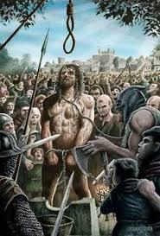
Judge 2: He is to be dragged through the middle of London to Smithfield, where he is to be hanged. Afterwards, his head is to be cut off and fixed above London Bridge for all to see. His body is to be cut up and divided into four quarters. This is to be a warning to all those who pass by.

Narrator: On August 23rd 1305, William Wallace was taken on a wooden cart to his place of execution. There he was hanged and his body disembowelled. His head and limbs were hacked off. The head was stuck on London Bridge and the limbs were sent to Newcastle, Berwick, Stirling and St Johnston (near Perth)

Work To Do
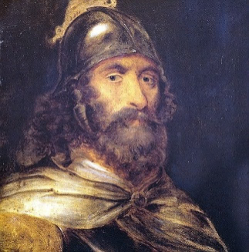
William Wallace
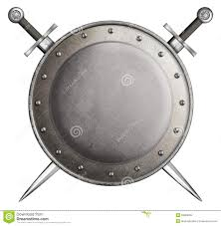
Terrorist or freedom fighter?

During Wallace’s life and in the years after his death, people have had different points of view on William Wallace.

The Scots look on William Wallace as a brave and heroic Freedom Fighter – someone who is willing to fight back against those wo want to invade and take over their country and will use violence to force the invaders out.

Some English people have described Wallace as a murderer or terrorist – someone who used violence and threats to force people, communities or governments to do what they want.

- Read the play about William Wallace’s trial
- Watch the film The Real William Wallace/Braveheart Fact or Fiction
- Research William Wallace using internet resources

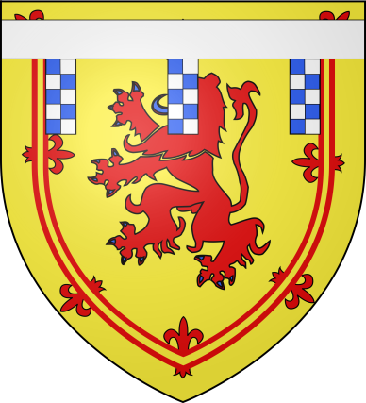
In groups of four you will write a report (one to one and a half sides of an A4 sheet of paper) explaining whether you think Wallace was a Terrorist or Freedom Fighter. Watch out for bias. Your report must take both points of view into account.

Robert Bruce

His Early Career
Robert Bruce’s grandfather had been one of the thirteen competitors who has claimed the throne following the deaths of Alexander lll and Margaret, the Maid of Norway. His father, Robert, had become Earl of Carrick, when he married a young widow, Marjorie of Carrick. The family lived in Turnberry Castle, and it was there on 11th July 1274, that Robert Bruce was born. In 1304, when his father died, he succeeded to vast family estates in Essex, Huntingdon, Dumfries and Aberdeen. Apart from very briefly helping Wallace, Robert Bruce was a loyal supporter of King Edward l of England, and so the family estates were untouched when the English took over Scotland.
In 1305 Wallace was dead and Scotland was completely under English control. But Wallace’s brutal treatment at English hands angered many Scots and encouraged them to rebel against the English. This time the Scots found a leader in Robert Bruce.

Work To Do

Write down the heading The Early Life of Robert Bruce. Copy down the passage below, filling in the blanks with an appropriate word.

Robert was born in ________ and lived in ________ castle. Until the death of Wallace in 1305, Robert Bruce was a strong supporter of King __________.

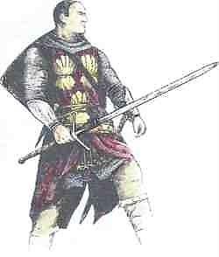
Bruce’s Quarrel With John Comyn

Before he took over the leadership of Scotland, Robert Bruce tried to come to an agreement with Balliol’s nephew, John Comyn. In 1306, they agreed to meet in Greyfriar’s Church in Dumfries.They quarrelled, and Comyn was stabbed and killed. Nobody is sure what happened. There are several different versions of events. Here are some of them.

Version 1
Robert suggested to Comyn that Comyn should support Robert’s claim to the Scottish throne. When Comyn refused, Robert struck him in anger and wounded him. The monks carried Comyn behind the high alter to treat him, but Robert Bruce’s men dragged him back out and stabbed him to death.

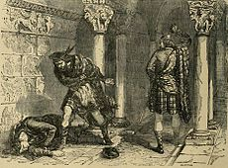
Version 2
Robert accused Comyn of betraying their plans to King Edward. Comyn refused to discuss the matter, and so Robert, in a temper, struck him with a knife. Comyn was not badly wounded, and was taken by monks to a room to recover. Two of Robert’s friends Lindsay and Kilpatrick, followed him there. And when they heard him say to the friars that he was not too bad they hacked him to death.
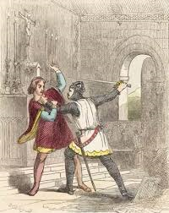
Version 3
Robert and Comyn quarrelled over who should be King. In the argument, Robert wounded Comyn. He rushed outside and said “I doubt I have killed him!” James Lindsay said, “If you doubt, I’d better make sure!” He went inside and murdered Comyn on the steps of the high altar.

Work To Do
Work in groups of four or five. Read all the accounts carefully and think about them. Each group will prepare a power point presentation on Comyn’s murder.
It should include:-
- Why they met
- The three versions of what happened
- Which version your group thinks is the most likely and why.

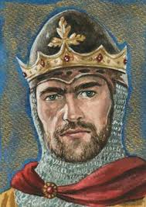
Robert Bruce Becomes King

After Comyn’s murder, Robert Bruce had two powerful enemies – Edward l who had trusted him, and the family and friends of John Comyn. Bruce was now on the run.

He headed first for Glasgow where he had an important meeting with the Bishop of Glasgow. Murder in a church would lead to excommunication (being barred from the church). The Bishop gave him absolution (said he was not guilty). Then, with his brothers and a small army raised from his tenants at Turnberry, he attacked and captured the English castle at Ayr.

In March 1306, Bruce was crowned King Robert l at Scone. There were no Crown Jewels and no Stone of Destiny. These had been taken by the English. In the presence of the Bishop of St Andrews ant the Bishop of Glasgow, the Countess of Buchan placed a simple gold coronet on his head.

Edward l was furious when he heard of this. The two Bishops were imprisoned: Bruce’s wife and daughter were also put in prison: the young Countess of Buchan was placed in a cage which was hung from the walls of Berwick Castle: his sister Mary was put in a similar cage outside Roxburgh Castle: three of Bruce’s brothers were executed: Bruce’s lands were given to others. Edward, swearing revenge on Bruce, hurried north at the head of an army.

At first the war went badly for Bruce. His little army was defeated at Methven. When he fell back to the west, along Loch Tay, they were attacked by Comyn’s friends, the MacDougalls of Lorne at The Pass of Brander. Finally< Bruce had to flee from Scotland and spent the winter on Rathlin Island off the coast of Ireland.

Bruce Gains Control of Scotland

In 1307, Bruce crossed again to Scotland, landing near Turnberry in Ayrshire. For the next two years he had to fight hard against Comyn’s friends. He was helped by the death of Edward l the “Hammer of Scots”. His son, Edward ll, was weak and unwarlike, and so there was no longer the same drive from England.

Bruce carried out a brilliant campaign of guerrilla warfare. Using speed and surprise, ne made several attacks against the English and his Scottish enemies, the Comyns. By the summer of 1308, Bruce had been joined by many supporters, including men from the Highlands and Western Isles. He was even able to call his first parliament at St Andrews. By 1322, his army was strong enough to begin to capture the great stone castles where the English held out. After he had taken them, Bruce was too wise to try to hang onto them. He preferred to destroy past of the walls, to make them useless to the English, and then abandon them. This kept his army together for fighting battles, instead of being used to defend castles up and down the country.
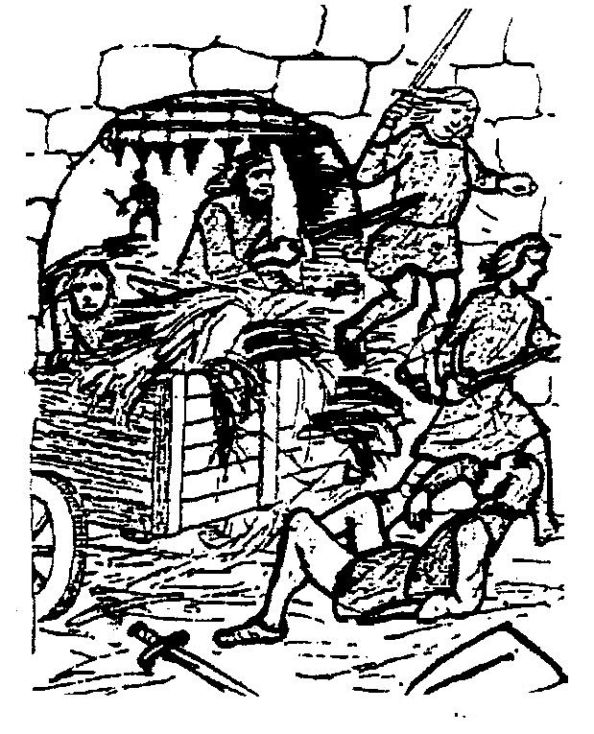

But capturing the castles was a difficult job. The Scots did not have the great catapults or towers needed for a long siege. Instead they had to rely on surprise. Perth was taken in a night attack. Linlithgow was taken by a trick. The assault party was hidden in the haycart of a local farmer, who drove into the castle and stopped right under the portcullis. The alarm was given and the English tried to drop the portcullis. It was held up by the haycart long enough to let the main body rush in and seize the castle.

In February 1313, Bruce’s good friend, Sir James Douglas, led a successful attack on Roxburgh Castle. His men scaled the walls and surprised the garrison at a party. Bruce’s nephew, Thomas Randolph, led the attack on Edinburgh Castle, up the steep cliffs and over the castle walls,

By the summer of 1313, only Stirling Castle remained in the hands of the English.

Work To Do
Copy and complete the table after reading the information under “Bruce becomes King” and “Bruce Gains Control of Scotland”

EARLY PROBLEMS | LATER SUCCESSES
- Bruce murders J_____ C______ and has to be crowned quickly.  - After being crowned King at S______ Bruce’s army was beaten at M______ in 1306  - Bruce then had to beat off an attack by the MacDougalls of Lorne at the Pass of B_______  - Bruce’s family was captured by the English. His wfe, sister and daughter were put in p______ and 3 of his brothers were e____________  - Bruce was forced out of Scotland to R_________ Isle where he spent the winter of 1306 | - T________ where Bruce landed in 1307 was the beginning of his fight back  - Death of E_________l in July 1307. Edward ll was weak and unwarlike  - A brilliant campaign of G______ W________ (hit and run attacks) e.g. Glen Trool and Loudon Hill.  - Defeated his Scottish enemies the C___________  - Bruce was able to hold his first Parliament at St A_________  - He recaptured the castles of L_______ R________ and E_______ from the English  - The only castle still to capture was S_________ Castle

The Battle of Bannockburn

Events Leading Up To the Battle
By June, King Roberts had won back all the important castles except Stirling. Edward Bruce, King Robert’s brother, was besieging Stirling Castle and he had arranged with the English Commander of the castle that the English would hand over the castle if King Edward ll of England did not come up to relieve it before Midsummer Day, 1314. King Edward therefore marched his forces north towards Stirling. The Battle of Bannockburn was about to begin.

The English Army
King Edward ll of England had ordered all his knights and their soldiers to gather at Berwick on June 10th. He wanted to put down the rebellion of Robert Bruce. In the English army, there were about 2,000 knights and 15,000 foot-soldiers from all parts of England. He also had some French and Dutch knights. It was said to be the biggest army that had ever left England. There was also a fleet of ships to keep the army supplied with food.

The Scottish Army

King Robert’s army was much smaller. There were only about 5,000 men altogether. 500 of these were knights on horseback and all the rest were spearmen and archers. There were also “sma folk” – a group of farmers, young people and people in charge of supplies. They were hidden out of sight in a valley to the west.
However the Scottish soldiers were very brave and they had been fighting well as a group for seven years. Also they loved and respected King Robert, their leader.
At the end of May, they gathered in the Torwood, which is to the south of Stirling.

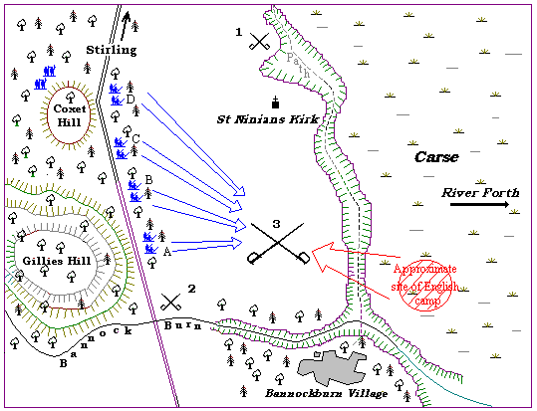

Scottish Advantages

The Scots were in a good position, as can be seen from the map.
- To the east was the River Forth and between the river and the Scots army there was marshland. This would be difficult for the English to cross.
- To the west was a forest and hills. This area would be difficult to fight in.
- To the north was Stirling Castle and the English would be unlikely to attack because of their agreement with Edward Bruce.
- To the south was the narrow gorge of the Bannockburn. It would be difficult for a large number of soldiers to go through this.
- The old road from the south ran across the Bannockburn and on towards Stirling. The English would come along this road. The Scots dug holes (called pots) on each side of the road and put spikes called calthrops into them. Then they covered them over with sticks and grass. Theis would damage the horses hoofs and force the English cavalry off the road.

Work To Do
Write down the heading “The Battle of Bannockburn” and answer the following questions.

- Copy and complete the following table:

King Edward ll’s Forces | King Robert’s Forces
Total _________men ________knights and _________foot-soldiers, archers and spearmen | Total __________ men including _____________ knights, archers and spearmen

- Take a copy of the map of the Battle of Bannockburn.
- Make a list of all the advantages the Scots had.
- What was the purpose of the calthrops?

Events Leading Up To the Battle
22nd June
The Scots saw the English army approaching. They saw the clouds of dust thrown up by the horses. The English soldiers had hardly rested for five day. They marched 20 miles a day in the heat of the summer wearing their armour. Yet the soldiers were in good shape. King Robert did not tell his men this.
23rd June
There were two important actions on this day.

- The Single Combat
One English knight called Sir Henry de Bohun challenged King Robert to a single combat (one man fighting another man). King Robert raised his battle-axe and struck a mighty blow. Sir Henry’s head was spit in two. This event put the Scots in good spirits.
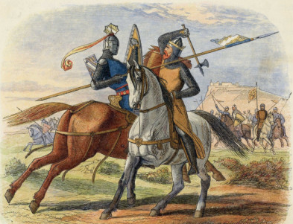

- The Schiltron
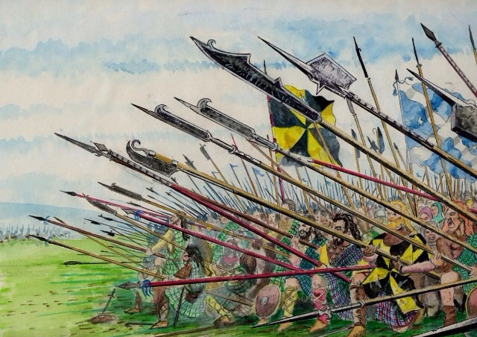
About 300 English knights under Sir Robert Clifford, tried to ride round about the Scots army in order to reach Stirling. King Robert sent Randolph to catch them. Near St. Ninian’s Kirk, the Scottish spearmen formed a schiltron. This meant they grouped closely together with their spears pointing outwards, so that they looked like a giant hedgehog. The English attacked, but they could not break through the Scottish ranks. Many English soldiers were knocked off their horses and killed. Others ran back. This event also raised the spirits of the Scots.

Work To Do
Write down the heading The Actions of the 23rd June
- Copy down and complete the following paragraph:

When the English army approached Stirling on ___________ and English knight ____________ recognised King Robert and challenged him to combat. ________ charged and missed King Robert who killed him with his __________.

In the meantime, and attempt made by __________ English knights to reach Stirling was stopped by Scottish spearmen who formed a ___________.

- Why do you think that the events of the 23rd June were important to the Scottish army?

The Battle of Bannockburn 1314
During the night, the English horsemen moved up onto firmer ground between Bannockburn and the Pelstream. King Robert saw that his enemies were now in a very narrow space. This was his chance to attack them. Before ordering his men to advance, he made up a speech to encourage them to fight well.
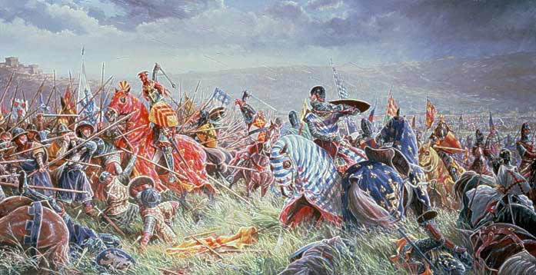
At dawn the Scots army advanced in four divisions. The English could hardly believe what they saw. The Scots were risking a battle out in the open – spearmen against an army of horsemen! Also, the Scots had much smaller numbers.

The English had to prepare quickly for battle.

The fighting began with each side firing arrows. At first the English were winning because their longbows were better than the Scottish bows. Edward Bruce’s men advanced and then the English vanguard (soldiers in the front) charged. Again the Scots formed schiltron and forced the English back. Because of the Scot’s attack, the English army fell apart, and their leader, the Earl of Gloucester was killed.

Now Randolf and Douglas moved up with their divisions against the rest of the English army. The English forces were squeezed together between Bannock Burn and the Pelstream that the got in each other’s way. The Scottish schiltrons pressed forward and forced the English back. The English horses were strumbling about and falling.

Now King Robert himself attacked with his division and the English soldiers were thrown back into the steams and marshland.
Bannock Burn was a terrible defeat for the English. Many soldiers werer killed and the noblemen were taken prisoner and held for ransom. Stirling Castle was handed over to the Scots. Bannock Burn was more than a battle won in a long hard war. It was to make the Scots free people again ruled by a man fit to be their King.

Work To Do
Write down the heading: The Main Battle 24th June

Work with your partner
Imagine you are an interviewer who has been sent to interview King Robert after the Battle of Bannockburn. Your partner is King Robert. You should ask them questions about how he felt before the battle and about the battle itself, about why he thought the Scots had won and about why the battle was important.

Write out the script for your interview and present your interview to the class.
Perhaps you could begin:
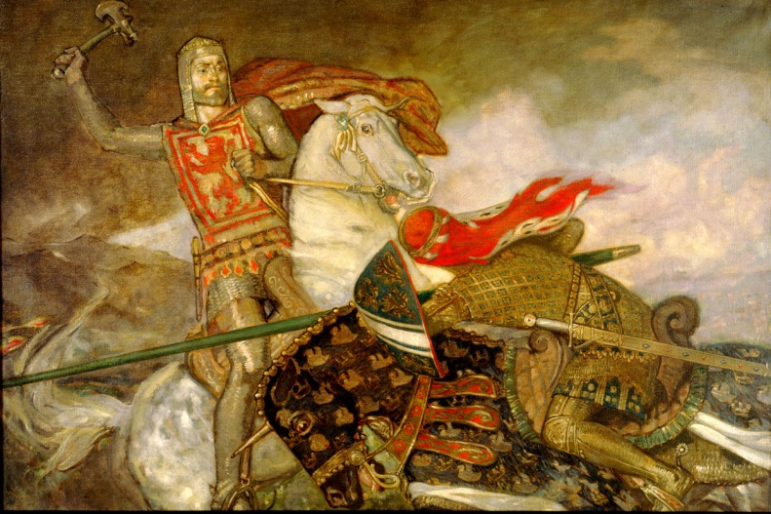
“Congratulations, King Robert on you magnificent victory against the English at Bannocknburn…..”

After Bannockburn

Though the Scots had won a breat victory at Bannockburn Edward II of England would not sign the peace treaty. This meant that the English had not given up their efforts to take over Scotland.
Bruce sent raiding parties into the north of England. The Scots laid waste to the English countryside and held English towns to randsom. Some Englishmen even accepted King Robert as their overlord in order to save their lands from devastation. Edward still refused to recognise Robert Bruce as the King of Scots.
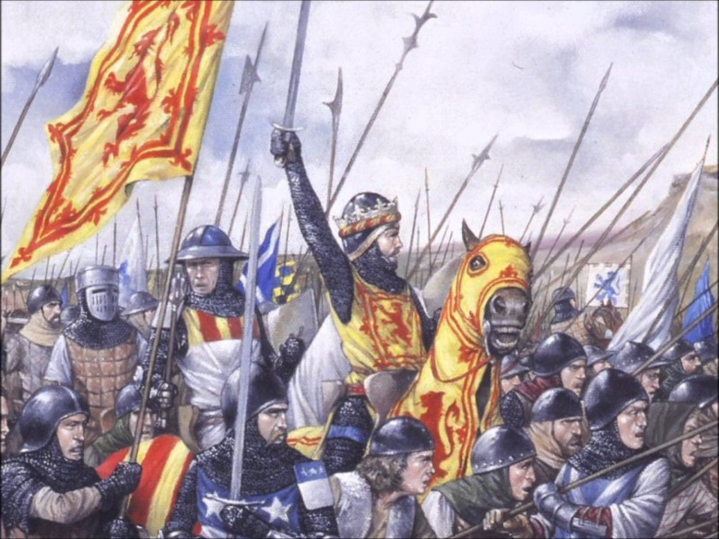

The Declaration of Arbroath

Robert the Bruce had the support of most of the Scottish people in his fight for independence from England. In 1320, the Scottish Lords sent a letter to the Pope. In the famous Declaration of Arbroath, they rejected English claims to Scotland. They said that they would never give up the struggle for Scotland’s freedom. This is part of the declaration:
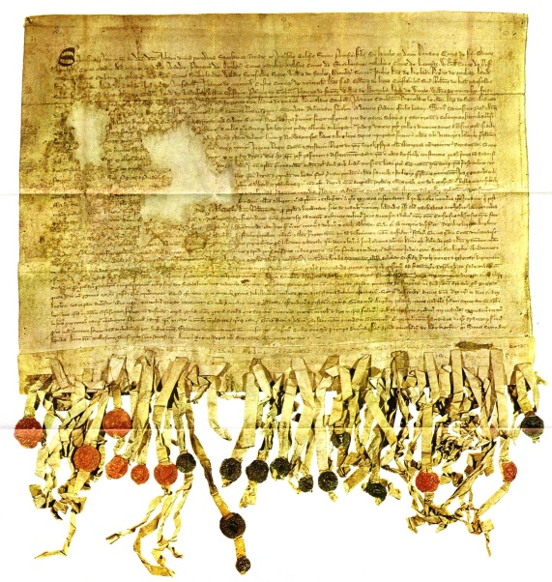
“For so long as one hundred men remain alive, we shall never submit to the domination of the English. It is not for glory, riches or honour that we fight: it is for freedom alone, which no good man gives up except with his life.”

The Declaration of Arbroath is one of the most important documents in Scottish history. In 1320 it convinced the Pope that the time had come persuade the English to accept a peace treaty. More recently the Declaration has been used as a rallying call for those people who wanted independence for Scotland.

Peace at Last

Edward II was murdered in 1327. The next year his son Edward III agreed in a treaty signed at Edinburgh and Northampton that:

“The realm of Scotland….. Shall remain forever to the eminent (importance) Prince, Lord Robert, by the grace of God, the King of Scots.”

The Death of King Robert
King Robert died, possibly of leprosy now known as Hansen's disease in 1329. His body was buried in Dunfermline Abbey. Before his death he had asked his good friend Sir James Douglas to take his heart in a casket to the Holy Sepulchre in Jerusalem. On his way there Sir James was killed but his body and the casket containing King Robert’s heart were returned to Scotland. King Robert’s heart was buried in Melrose Abbey, although there is some doubt over whether it is still there.

The Treaty signed in Edinburgh and Northampton did not bring lasting peace between Scotland and England. This did not come until the Union of the Crowns in 1603 when James VI of Scotland became James I of England as well.

Work To Do
Answer the following under the heading: After Bannockburn

- Copy down and complete the following:

The declaration of Arbroath
In 1320 the Scottish ________________ sent a letter to the ________
Declaring Scotland’s independence from England and promising to continue the fight for Scotland’s ____________________.

- On a large piece of paper copy out neatly the extract from the Declaration of Arbroath on the previous page. Try to make it anancient document, a bit frayed round the edge. Treatment with a moist teabag gives a nice brown colour. It should have the seals of Scottish nobles at the bottom.

- Where and when was a peace treaty finally made between Scotland and England?

- Write a paragraph under the heading: The Death of King Robert I

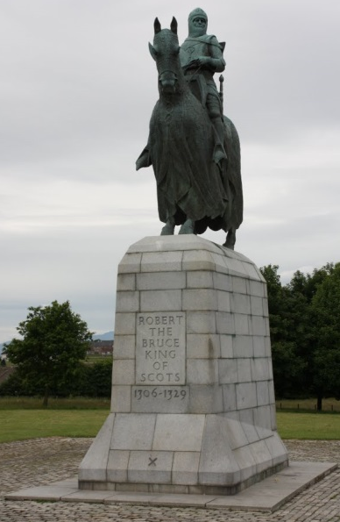
In your paragraph mention the following:
- When King Robert died
- What he dies of
- Where he was buried
- The instructions he gave Sir James Douglas
- What eventually happened to the casket with his heart

Extention Work

Write an obituary for Robert The Brice. Obituaries appear in newspapers. They appear after the death of someone well-known and tell a bit about their life. They describe the important things that person has done. Do your research by using this booklet and internet resources.

