**Carrick Academy History**

*National 5*



Prelim and final exam preparation booklet

Kevin.riley@south-ayrshire.gov.uk

This booklet contains examples of the types of questions which will appear in the prelim and final National 5 History exam.

Ask Mr Riley to mark any work that you do to ensure you understand what is required for each question type. **Focus on the questions you find hardest.**

How to answer the questions **Pages 3-9**

How long should you spend on each question **Page 10**

**Knowledge questions**

**A.** Describe questions **Pages 11-12**

**B.** Explain questions **Pages 13-14**

**C.** 9 Mark questions **Pages 15-17**

**Sources questions**

**D.** How fully? questions **Pages 18-25**

**E.** How useful? questions **Pages 26-33**

**F.** Comparison questions **Pages 34-42**

**Revision topics and ideas**

The Cold War **Page 43**

The Atlantic Slave Trade **Page 44**

Migration and Empire **Page 45**

Revision ideas **Page 46**

Internet resources **Page 47**

**How to answer…**

* ***DESCRIBE***  *-* list a number of points separated by full stops.

1 mark for each **simple** point; 2 marks for each **developed** point

**Simple point “**During the Highland Clearances many crofters were forced off their land to make way for sheep.”

**Developed point** **“**During the Highland Clearances many crofters were forced off their land to make way for sheep. This often resulted in riots as people fought against their landlords evicting them from their homes.”

**Sample Question**

Describethe conditions for slaves on board ships during the middle passage.

(4)

**Model Answer**

There were many different issues with the conditions on board slave ships during the middle passage. Below deck, where the slaves were held for most of the journey, it was almost always dark and very warm. (1) Slaves were often only fed once a day with a very small amount of food. (2) Slaves were chained together in very tight spaces, often unable to move. (3) There were regular outbreaks of disease amongst the slaves due to the poor conditions, leading many slaves to die.(4)

* *EXPLAIN -* use A-B-C

1 mark for each times you do all of this:

**(A)nswer:** *say a point that relates to the answer e.g. Many people left Ireland due to the potato Famine”*

**(B)ecause:** write the word “*because”*

**(C)omment:** explain what your point has to do with the question e.**g. “**it *stopped people being able to eat or make money”.*

**Sample Question**

Explain the reasons why so many slaves hated being on slave ships? (6)

**Model Answer**

One reason slaves hates slave ship was the heat ***because*** it was very uncomfortable due to the high temperatures below deck (1) Another reason was the lack of food ***because*** it often led to the slaves becoming ill or dying.(2) Another reason slaves hated the slave ship was the cramped conditions ***because*** this often led to them getting sore muscles or catching diseases from other slaves (3) Another reason was the beatings they were given ***because*** this led to slaves constantly living in fear that they could be beaten up at any time (4) Another reason the slaves hated slave ships was the uncertainty ***because*** slaves often had no idea where they were going and this frightened them greatly(5)A final reason slaves hated slave ships is the lack of communication **because** they often spoke a different language from the people they were placed beside so couldn`t talk to them (6)

***HOW FULLY?* -** What the source does and doesn`t tell you

**A***nswer* Start by writing “This source tells us about (wording of the question) to a certain extent”

**I***ncludes* Include **at least two** relevant facts that the source tells us about the topic (in your own words)

**D***oesn’t* *include* Include **at least** **two** relevant facts that the source *does not* tell us about the topic

**REMEMBER: say whether the points came from the source or your own knowledge**

*Your overall answer needs five or six points in it*

**Sample Question**

**Source A is about why many Irish immigrated to Scotland in the 1840s.**

Among those who moved to Scotland, the largest group of immigrants came from Ireland. Irish immigration continued steadily until the 1840s. The Irish potato famine of the mid-1840s however led to a sharp increase in this immigration. It led to great poverty and some landlords evicted those who could not pay their rent. Transport costs were cheap, and wages in the west of Scotland continued to be higher than those in Ireland. However, by the end of the 19th century it was not just the Irish who were attracted to Scotland.

1. How fully does Source A explain why people moved to Scotland between 1830 and 1939? (Use Source A and recall.)

**(6)**

**Model Answer:**

Source A explains why people moved to Scotland between 1830 and 1939 to a certain extent. One thing the source tells us about why people moved to Scotland between 1830 and 1939 is that due to the famine of the mid-1840s immigration increased sharply. ***(1)*** The source also states that some people moved because they had been evicted by landlords for defaulting on their rent. (2) Another point from the source is that wages were higher in Scotland than in Ireland which attracted immigrants.(3) However, one thing the source does not mention about why people moved to Scotland between 1830 and 1939 is that some moved to join family already in Scotland . (4) The source also fails to say that many Irish got work building the railways in Scotland . (5) In addition, the source does not mention that Jewish immigrants came to Scotland to escape persecution in Nazi Germany during this period. (6)

* ***HOW USEFUL?*** - 5Ws question

**After each W always say “this is useful/not useful for finding out about (insert the wording of the question) because…”**

**W**ho created it? Who made the source **and** if this is useful /not useful for finding out about whatever the question is?

**W**hen was it made? When the source was created **and** why is this useful or not for finding out about whatever the question is? (Does it make it a primary or secondary source)

**W**hy made? Why was the source made (to inform or persuade) **and** why this makes it more/less useful for finding out about whatever the question is?

**W**hat does it say? What relevant facts does the source tell us about the question **and** is this useful for finding out about whatever the question is?(is it true or false?)

**W**hat is not in it? Are there pieces of information missing that are relevant to the question? If so say this makes the source less useful because it means important info is missing.

1. Evaluate the usefulness of Source A as evidence of the effects of poverty in Britain around 1900.

(You may want to comment on who wrote it, when they wrote it, why they wrote it, what they say or what has been missed out.)

**(5)**

**Model Answer**

Source A is useful to a certain extent as evidence of the effects of poverty in Britain around 1900 *(Opening sentence).* The author is a campaigner for social change *which is useful as evidence of the effects of poverty in Britain around 1900 because* he is an eyewitness to poverty but they may also be biased as they want action to be taken to end poverty ***(Who?)****.* This source was created in 1890, *which is useful as evidence of the effects of poverty in Britain around 1900 because* it is a primary source ***(When?)****.* The source was written to show the extent of poverty that existed and to urge action to be taken, therefore *this may be less useful as evidence of the effects of poverty in Britain around 1900 because* it may be exaggerated ***(Why?).***The source tells us about a family who live in a cellar alongside animals *which is useful as evidence of the effects of poverty in Britain around 1900 because* it is a detailed example of living conditions which were common at that time. ***(What)****.* The source does not tell us that many homes were damp which led to high instances of tuberculosis among the poor *which makes the source less useful as evidence of the effects of poverty in Britain around 1900 because this was important information that has been missed out.* ***(What not).***

* ***COMPARISON*** - Describe two **differences** or **similarities**

1. Describe a similarity/difference in your own words and then quote **exactly** what the 1st and 2nd source say about this.
2. Repeat step 1 again
3. ***If you`ve given two example of the source agreeing* write**

“ Source A and B agree on (then add the wording of the question)”

1. ***If you`ve given two example of the source disagreeing*** **write**

“ Source A and B disagree on (then add the wording of the question)”

**Sample Question**

Sources A and B describe the results of the Montgomery Bus Boycott.

Source A

Throughout the boycott a young black preacher inspired the black population of

Montgomery. His name was Martin Luther King and this was to be his first step towards becoming the leading figure in the Civil Rights Movement. The boycott lasted over a year until eventually the courts decided that segregation on Montgomery’s buses were illegal. On its own, the bus boycott only had limited success. Montgomery remained a segregated town. There were still white-only theatres, pool rooms and restaurants.

Source B

The bus company’s services were boycotted by 99% of Montgomery’s African Americans for over a year. As a result of the protest, the US Supreme Court announced that Alabama’s bus segregation laws were illegal. However, most other facilities and services in Montgomery remained segregated for many years to come. As a result of the boycott, Martin Luther King became involved in the Civil Rights Movement. He went on to become an African American leader who was famous throughout the world.

1. Compare the views of Sources A and B about the results of the Montgomery Bus

Boycott. (Compare the sources overall and/or in detail.)

**(4)**

**Model Answer**

The sources agree that the success of the boycott was limited. **(1)**This is shown in Source A which says "the boycott only had limited success" and Source B agrees that "most of the facilities and services in Montgomery remained segregated" (2) The sources also agree about the impact the boycott had on Martin Luther King. (3)Source A says the boycott was his “first step to becoming a leading figure in the Civil Rights Movement” and Source B agrees that “As a result of the boycott, Martin Luther King became involved in the Civil Rights Movement”. (4) .Therefor the sources agree on the results of the Montgomery bus boycott.

***9 MARK QUESTION*** *-* Intro, 2/3 ABC factors and then choose most important one.

1 mark having a short introduction setting the scene and listing the factors you are going to talk about

Up to 5 marks Make 5 **ABC** points (like explain questions) about 2 or 3 factors (including the one in the question if there is one)

1 mark State which factor you think is most important.

2 marks Give 2 reasons why you think that was **the most important** **reason**. Use real facts (and don`t just repeats what you`ve already written in the main essay.)

**REMEMBER: Make sure each of your intro, points, conclusion and conclusion reasons are all separate sentences.**

**Sample Question**

To what extent was ideological differences the main reason why the Cold War broke out?

(9)

**Model Answer**

For almost 45 years the USA and the USSR were sworn enemies, who came close to all out nuclear war with each other on a number of occasions. But why did this conflict begin between these two great powers? In this essay I shall discuss the importance of ideological differences, nuclear weapons and the delay by the USA to come to the USSR`s aid after Germany attacked it.(1)

Ideological differences were important to the outbreak of the Cold War ***because*** the USA and the USSR had completely different views on how the world should be ran, with the USA believing capitalism was the best system and the USSR backing communism. (2) Ideology was also important **because** the USSR had been trying to spread communism throughout Eastern Europe and the USA believed that, if it did not stop the USSR, they could spread communism thought the entire world. (3)

Another factor in the outbreak of the Cold War was nuclear weapons **because** the USA had developed nuclear weapons and used them on Japan without informing the USSR, which made the USSR suspicious of America. (4) Nuclear weapons were also important in the outbreak of the Cold War **because** the USSR developed its first nuclear weapon in 1949 and the USA felt further threatened by this. (5)

Furthermore, mistrust was a factor in the outbreak of the Cold War **because** after Germany had attacked the USSR during World War Two, the USSR believed that the USA had purposefully taken too long to come to Russia’s aid so that it would become week as a result of the German attack. (6)

In conclusion, I believe that the most important factor in the outbreak of the Cold War was nuclear weapons. (7) I believe this because, without the dropping of the first nuclear weapon by the USA on Japan, the USSR might not have felt so intimidated and defensive. (8) I also believe that this was important because the USSR`s development of nuclear weapons lead to the arms race which was a major factor through the entire cold war. (9)

**How long should I spend on each question?**

Compare 4 Marks

Describe 4 Marks

How Useful 5 Marks

Explain 6 Marks

How Fully 6 Marks

9 mark question 9 Marks

4 MARK QUESTIONS = 6 minutes

5 MARK QUESTIONS = 8 minutes

6 MARK QUESTIONS = 11 minutes

9 MARK QUESTIONS = 17 minutes

**Describe questions**

**The Cold War**

**A1.** Describe reasons why many Americans were opposed to the Vietnam War

**A2.** Describe the events which led up to the formation of the Warsaw Pact in 1955.

**A3.** Describe the tactics used by the Americans in the Vietnam War.

**A4.** Describe the role of the USSR during the Cuban Missile Crisis.

**A5.** Describe the role of the USA during the Cuban Missile Crisis.

**A6.** Describe steps taken by the USA and USSR to reduce tensions during the 1960s and 1970s.

**A7.** Describe what was meant by the ‘Cold War’.

**A8.** Describe the differing American views on the Vietnam War

**The Atlantic Slave Trade**

**A9.** Describe the different ways that people became slaves.

**A10.** Describe the ways that abolitionists tried to win support for their cause.

**A11.** Describe the ways that slaves were prepared and sold in the Americas.

**A12.** Describe the different stages of the Triangular Trade.

**A13.** Describe conditions for slaves during the Middle Passage.

**A14.** Describe what happened to slaves at the end of the Middle Passage.

**A15.** Describe the ways that Britain profited from the Slave Trade.

**A16.** Describe the tactics used by people who opposed slavery to win support for their cause.

**A17.** Describe the different stages of the triangular trade

**Migration and Empire**

**A18.** Describe the reasons that large numbers of Irish immigrants moved to Scotland

**A19.** Describe the ways that many Scots emigrants kept links with Scotland in their new homelands.

**A20.** Describe the work done by Irish immigrants in Scotland.

**A21.** Describe the impact of Scottish emigrants on their new overseas homes.

**A22.** Describe the experience of Irish immigrants in Scotland.

**A21.** Describe the experience of different immigrant groups in Scotland.

**A23.** Describe ways that Scottish emigrants were encouraged to move abroad between 1830 and 1939.

**A24.** Describe relations between the Scottish people and immigrants to Scotland.

**A25.** Describe how Scots tried to keep their traditional Scottish way of life in their new countries.

**Explain questions**

**The Cold War**

**B1.** Explain why the Cuban Missile Crisis increased tensions between East and West.

**B2.** Explain why the USA found it so difficult to defeat the Viet Cong.

**B3.** Explain why the Soviet Union collapsed in 1991.

**B4.** Explain why the Berlin Wall was built in 1961.

**B5.** Explain why the Cuban Missile Crisis started and ended in 1962.

**B6.** Explain why a Cold War developed after 1945.

**B7.** Explain why views on the Vietnam War changed in the USA.

**B8.** Explain why the Cold War came to an end in the early-1990s.

**B9.** Explain the reasons why the USA and the Soviet Union followed a policy of détente after 1968.

**The Atlantic Slave Trade**

**B10.** Explain why many people in Britain were opposed to slavery.

**B11.** Explain why so many people in Britain opposed the abolition of slavery.

**B11.** Explain why there was growing support for abolishing slavery by the 1780s.

**B12.** Explain why many people were in favour of the Slave Trade in the 1700s.

**B13.** Explain why slave resistance on the plantations was mainly unsuccessful.

**B14.** Explain how Britain benefitted from its involvement in the Atlantic Slave Trade.

**B15.** Explain how campaigners such as William Wilberforce were able to win parliamentary support to abolish slavery.

**B16.** Explain the reasons why the slave trade was important to British cities.

**Migration and Empire**

**B17.** Explain why many Irish people choose to move to Scotland in the 1800s.

**B18.** Explain why many Scots left their homeland between 1830 and 1939.

**B19.** Explain why many Scots opposed Irish immigration.

**B20.** Explain how Scottish emigrants helped develop the countries that they settled in.

**B21.** Explain why many Highlanders left their homes in the nineteenth century.

**B22.** Explain why many lowland Scots left Scotland between 1830 and 1939.

**B23.** Explain the reasons why lowland Scots emigrated between 1830-1939.

**B24.** Explain why so many immigrants came to Scotland after 1830.

**9 mark questions**

**The Cold War**

**C1.** How important was ideology to the Cold War starting?

(You must use recalled knowledge to present a **balanced assessment** of the influence of different factors and come to a **reasoned conclusion**)

**C2.** To what extent were economic problems the main reason for détente between the USA and Soviet Union?

(You must use recalled knowledge to present a **balanced assessment** of the influence of different factors and come to a **reasoned conclusion**)

**C3.** To what extent were the actions of Ronald Reagan the main reason that the Soviet Union had collapsed by 1991?

(You must use recalled knowledge to present a **balanced assessment** of the influence of different factors and come to a **reasoned conclusion**)

**C4.** How successful were the Vietcong tactics in defeating the USA during the Vietnam War?

(You must use recalled knowledge to present a **balanced assessment** of the influence of different factors and come to a **reasoned conclusion**)

**C5.** To what extent did the USA benefit most from the outcome of the Cuban Missile Crisis?

(You must use recalled knowledge to present a **balanced assessment** of the influence of different factors and come to a **reasoned conclusion**)

**C6.** To what extent did the USSR benefit most from the process of détente?

(You must use recalled knowledge to present a **balanced assessment** of the influence of different factors and come to a **reasoned conclusion**)

C7**.** How important where political beliefs for the development of the Cold War between 1945 and 1955?

(You must use recalled knowledge to present a **balanced assessment** of the influence of different factors and come to a **reasoned conclusion**)

**The Atlantic Slave Trade**

**C8.** How important was religion to the abolition of slavery by Britain?

(You must use recalled knowledge to present a **balanced assessment** of the influence of different factors and come to a **reasoned conclusion**)

**C9.** How successful was slave resistance in abolishing the slave trade?

(You must use recalled knowledge to present a **balanced assessment** of the influence of different factors and come to a **reasoned conclusion**)

**C10.** To what extent was political opposition the main reason that Britain took so long to abolish the use of slavery?

(You must use recalled knowledge to present a **balanced assessment** of the influence of different factors and come to a **reasoned conclusion**)

**C11.** How important where Europeans to the slave trade occurring?

(You must use recalled knowledge to present a **balanced assessment** of the influence of different factors and come to a **reasoned conclusion**)

**Migration and Empire**

**C12.** To what extent was poverty the main reason that many Scots left the country in the 1800s?

(You must use recalled knowledge to present a **balanced assessment** of the influence of different factors and come to a **reasoned conclusion**)

**C13.** How important was religious differences for Scottish opposition to Irish immigration?

(You must use recalled knowledge to present a **balanced assessment** of the influence of different factors and come to a **reasoned conclusion**)

**C14.** To what extent did Scotland benefit from mass immigration in the nineteenth century?

(You must use recalled knowledge to present a **balanced assessment** of the influence of different factors and come to a **reasoned conclusion**)

**C15.** To what extent was the USA the country where the emigrant Scots had the biggest impact?

(You must use recalled knowledge to present a **balanced assessment** of the influence of different factors and come to a **reasoned conclusion**)

**C16.** To what extent did emigrant Scots make a valuable contribution to the world?

(You must use recalled knowledge to present a **balanced assessment** of the influence of different factors and come to a **reasoned conclusion**)

**C17.** How important where the Highland clearances to people leaving Scotland?

**How fully? questions**

**The Cold War**

**Source A**

By 1960 the situation in East Berlin was very dangerous. A new East German labour law, which stopped workers from going on strike, had led to growing unrest in the factories. The East German government’s reforms of agriculture had led to shortages of food and higher prices. All of this led to a massive increase in the numbers of refugees fleeing to the West. At a meeting of the Warsaw Pact states, Khrushchev had been informed about the situation. In the six months up to June 1961, 103,000 East Germans had fled through Berlin. The decision to act was taken.

**D1.** How fully does Source A describe the reasons that there was a crisis in Berlin in 1961? (Use source A and recall.)

**Source B**

In its early stages, the war in Vietnam had nothing to do with the USA. American involvement began when it was asked by its ally, France, for assistance. France was fighting to regain control over its former colony. The Americans agreed. They disapproved of French colonialism, but feared Communism more. They believed that they could establish a friendly government in South Vietnam, under the leadership of President Diem. By the early 1960s an increase in Vietcong attacks in South Vietnam led to a fear that a civil war was developing.

**D2.** How fully does Source B explain the reasons that the USA became involved in a full-scale war in Vietnam? (Use source B and recall.)

**Source C**

By the early 1970s President Nixon had begun to withdraw US troops from Vietnam. Although the fighting did not end immediately, it seemed like the beginning of peace. Gradually the Vietnamese peace had a positive influence over other areas of superpower relations. The personalities involved were also important. Presidents Nixon and Carter enjoyed the increased popularity they won as peace-makers. The Soviet leader Brezhnev welcomed the improved relations with America because he recognised the perils of all-out nuclear war. Brezhnev was also keen on peace because it left him free to concentrate on problems within the Soviet Union.

**D3.** How fully does Source C explain why relations between the USA and Soviet Union improved in the 1970s? (Use source C and recall.)

**Source D**

The Allies met at Potsdam in July, 1945. The new American leader, Truman, distrusted the Russians and Stalin did not trust him. Stalin had good reason for being uneasy. While the Allies met at Potsdam a message had reached Truman informing him that America had successfully tested its first atomic bomb. On the 6th of August, the USA dropped an atomic bomb on Hiroshima; three days later, it dropped a second on Nagasaki. Truman had not told Stalin that this was about to happen. Wartime friends, who had fought together to defeat a common enemy, were about to become peacetime enemies.

**D4.** How fully does Source D explain why the Cold War started? (Use source D and recall.)

**Source E**

On 12 August 1961 a record 4000 East Germans fled to West Berlin to start a new life in the West. Those who left were often young and well educated. In the small hours of 13 August, Soviet and East German “shock workers” closed the border and put barbed wire across the streets. The East Germans claimed that enemy agents had been stationed in West Berlin. The agents were using Berlin as a centre of operations against East Germany and the Soviet Union. Berlin had become a divided city.

**D5.** How fully does Source E describe reasons that the Berlin Wall was built? (Use source E and recall.)

**Source F**

North Vietnam suffered widespread destruction but still triumphed. America realised too late that the real war in Vietnam was not just a military one but one for “the hearts and minds” of the peasants. American troops failed to cope with the guerrilla tactics of the Viet Cong. The communists were backed militarily by China and Russia. By the late 1960s all that the American troops wanted was to go home.

**D6.** How fully does Source F explain why the USA lost the Vietnam War? (Use source F and recall.)

**Source G**

The tensions of the 1960s, which had brought them to the brink of nuclear war, caused the superpowers to rethink their plans. This led to a thaw in the Cold War. Both sides had important reasons to seek a relaxation in tensions. Leonid Brezhnev and the rest of the Soviet leadership felt the economic burden of the nuclear arms race was too great. The American economy was also in financial trouble as a result of the Vietnam War. Johnson, and to a lesser extent Nixon, were having difficulty funding the government welfare programme.

**D7.** How fully does Source G explain why both the USA and USSR wanted détente by the 1970s? (Use source G and recall.)

**The Atlantic Slave Trade**

**Source A**

John Newton persuaded William Wilberforce to join the Society for the Abolition of the Slave Trade and Wilberforce soon became its leader. Newton was a former slave trader who became an anti-slavery campaigner. Wilberforce used evidence gathered by abolitionists to try to persuade parliament to end the slave trade. For 18 years he introduced anti-slavery motions in parliament. However, the slave traders put their case to parliament and Wilberforce’s arguments failed to win enough support. As a consequence, Wilberforce published even more horrific accounts of the slave trade.

**D8.** How fully does Source A describe the role of William Wilberforce in the campaign for the abolition of the slave trade? (Use source A and recall.)

**Source B**

Cities in the west of Britain benefited from the Atlantic slave trade. By 1800, Liverpool profited most directly from the transportation of human beings as slaves. Glasgow and Bristol developed their own specialist areas which were linked to the trade. Glasgow had the largest share of the British tobacco trade and this helped the city’s economic development. Profits from the tobacco trade also contributed to the development of industry in Glasgow. In Bristol, merchants profited from the sugar trade. All of these activities were based on Britain’s involvement in the Atlantic slave trade.

**D9.** How fully does Source B describe reasons that the slave trade was so important to Britain? (Use source B and recall.)

**Source C**

During the late nineteenth century, attitudes towards the slave trade were changing. More people began to think of Africans as fellow human beings and felt that they should be treated as such. Britain’s trading interests were also changing. Trade with India and East Asia was growing while trade with the West Indies had become less important to Britain. Many merchants supported free trade. They argued that slavery was an inefficient way to produce sugar. In 1807, a new law made it illegal for British people to buy slaves in Africa.

**D10.** How fully does Source C describe why Britain abolished slavery in 1807? (Use source C and recall.)

**Source D**

The supporters of the slave trade were well organised and influential. Although Wilberforce introduced his first bill to abolish it in 1789, it took a full eighteen years to end the evil. Plantation owners were often Members of Parliament who also had the support of George III. As a result, they created many difficulties for the abolitionists.

**D11.** How fully does Source D explain why it took so long to persuade the British Parliament to abolish the slave trade? (Use source D and recall.)

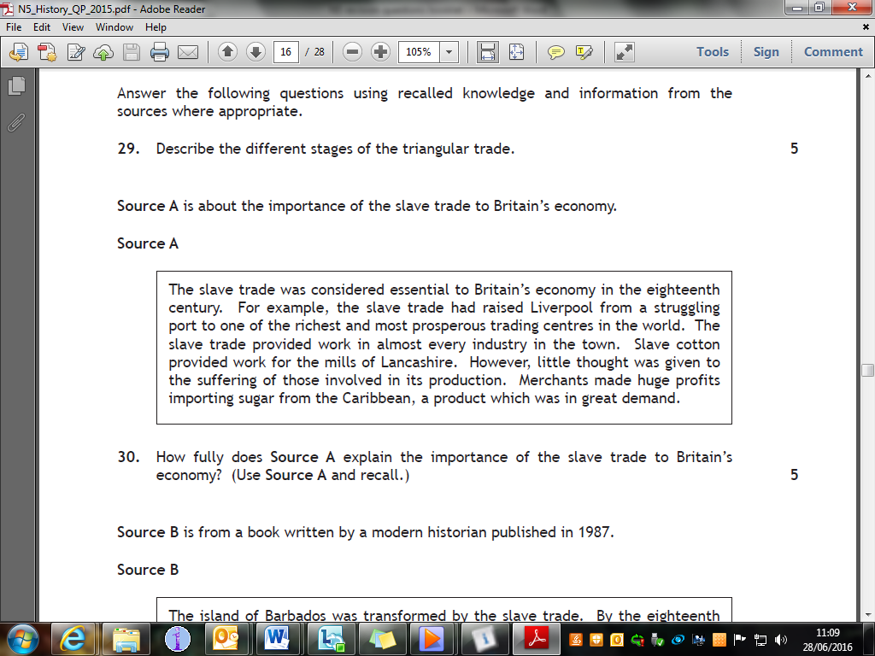

**D12.**

**Migration and Empire**

**Source A**

The Irish immigrants were not very well-off and the native Scots often did not welcome them. The church gave them a place to worship and a sense of security. Immigrants knew that they could be baptised, married and buried according to their religion. The priests usually spoke Irish so there was someone to whom they could explain their problems. Over time a number of Catholic churches were established in the west of Scotland. The church became a centre of social life and gave the immigrants an opportunity to meet their fellow countrymen.

**D12.** How fully does Source A describe the role that the Catholic Church played in the life of Irish immigrants in Scotland? (Use source A and recall.)

**Source B**

The lairds had discovered that their land would yield far greater profits from sheep and therefore encouraged their tenant farmers to leave. Poor soil and harsh weather made farming difficult and life in the Highlands became even worse with the repeated failure of the potato crop after 1846. In fact the Highland Scot was affected by conditions over which he had no control. However, many Highlanders preferred the countries of the Empire to Scotland’s dismal industrial cities. Many Lowland craftsmen were also leaving at this time.

**D13.** How fully does Source B explain why so many people left Scotland in the 1800s? (Use source B and recall.)

**Source D**

Many Scots had developed a resentment of Irish immigrants in the nineteenth century. Newspapers were eager to describe the violent activities of groups of Irish men. One of the most notorious stories was about drunken Irishmen rampaging around the town of Hamilton and terrifying the inhabitants until soldiers arrived to restore order. Many Irishmen often worked for weeks with little opportunity for a rest. In Ayr the Irish were blamed for using up most of the money available to support the poor. In Glasgow they were blamed for crimes of theft and burglary.

**D15.**  How fully does Source D describe the reasons that many Scots resented the Irish immigrants? (Use source D and recall.)

**Source E**

Mr Macdonald, the headmaster, said that he had faith in Canada. Many of his best pupils who were now living in Canada were succeeding. This was obvious from the money and letters they sent home to their parents. He then introduced the Canadian immigration agent, who spoke first in Gaelic and then in English. He said Canada was a huge country which offered great opportunities for farming. He enthusiastically praised the country as he showed view after view of scenes of Canada on the screen.

**D16.** How fully does Source E describe reasons that many Scots left their homeland in the nineteenth century? (Use source E and recall.)

**Source F**

South-West areas of Scotland like Ayrshire were close to Ireland and so attracted Irish people to go there. A large number settled in the Glasgow area as many ships with cheap fares arrived there. During the year 1848 the number of people landing in Glasgow numbered a thousand a week. Many Irish people went to Dundee where they found work in the Dundee jute industry. Some Irish men and women came to Scotland for just part of the year and then returned home. They mainly worked on farms at times such as the harvest.

**D17.** How fully does Source F explain why Irish people moved to Scotland during the nineteenth century? (Use source F and recall.)

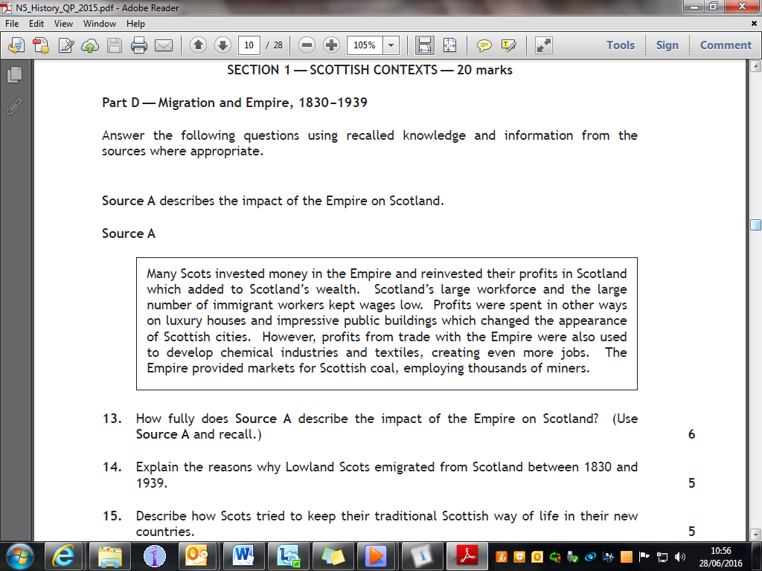

**D18**

**How useful? questions**

**The Cold War**

**Source A** is an excerpt from a speech given by Soviet Premier Leonid Brezhnev in 1976

We are attempting to follow the path of peaceful co-existence. We are trying to bring about lasting peace to reduce, and in the longer term to eliminate, the danger of another world war. This is the main element of our policy towards the capitalist states. It may be noticed that considerable progress in this area has been achieved in the last five years.

**E1.** Evaluate the usefulness of Source A as evidence of Soviet attitudes towards détente. (You may want to comment on who wrote it, when they wrote it, why they wrote it, what they say or what has been missed out)

**Source B** is from a speech given by US President Ronald Reagan in 1983.

Our efforts to rebuild America’s forces began two years ago. For twenty years the Soviet Union has been accumulating enormous military might. They didn’t stop building their forces, even when they had more than enough to defend themselves. They haven’t stopped now. I know that all of you want peace, and so do I. However, the freeze on building nuclear weapons would make us less, not more, secure and would increase the risk of war.

**E2.** Evaluate the usefulness of Source B as evidence of why the process of détente had come to an end in the early-1980s. (You may want to comment on who wrote it, when they wrote it, why they wrote it, what they say or what has been missed out)

**Source C** is from a document written by President Kennedy about the crisis in Berlin 1961.

It seems particularly stupid to risk killing a million Americans over an argument about access rights on a motorway or because the Germans want Germany reunited. If I’m going to threaten Russia with nuclear war, it will have to be for much bigger and more important reasons than that.

**E3.** How useful is Source C as evidence of American policy towards Berlin in 1961? (You may want to comment on who wrote it, when they wrote it, why they wrote it, what they say or what has been missed out)

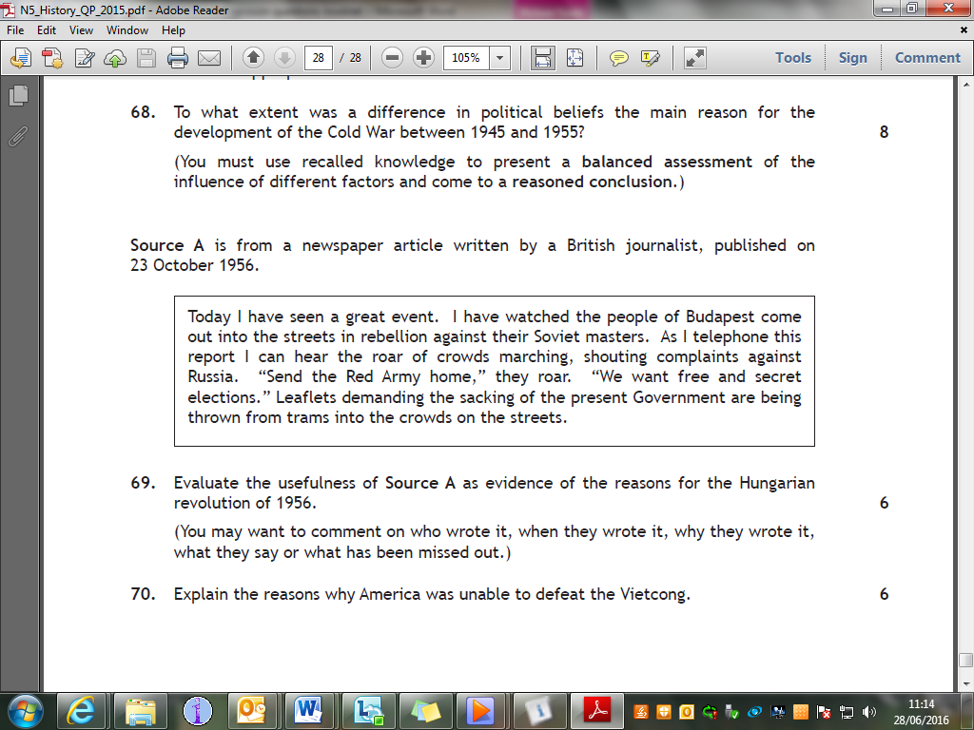

**E4.**

**The Atlantic Slave Trade**

**Source A** is from the diary of slave ship captain, written in 1795

Troublesome slaves were kept in chains and only let on the deck a few at a time for exercise. To keep the slaves as healthy as possible the crew would whip them to make them dance during exercise time. In desperation some slaves tried to jump overboard. Many slaves died during the middle passage from harsh treatment, poor food and disease. So did many of the crew.

**E5.** Evaluate the usefulness of Source A in describing the experiences of slaves on-board slave ships. (You may want to comment on who wrote it, when they wrote it, why they wrote it, what they say or what has been missed out)

**Source B** is from a book written by a modern historian

The British needed all the military help they could get in the 1790s when they faced slave unrest in Dominica, St Lucia and Grenada. Their greatest concern was for Jamaica, which was the biggest, the richest and most troublesome of their slave colonies. By the early nineteenth century, the island was undergoing what seemed like an endless series of revolts. In one of the worst rebellions, 226 properties were damaged at a cost estimated to be £1 million.

**E5.** Evaluate the usefulness of Source B as evidence of slave revolts in the Americas. (You may want to comment on who wrote it, when they wrote it, why they wrote it, what they say or what has been missed out)

**Source C** is from a book by Harriet Jacobs about her experience as a slave, written years later in 1861

On one of these sale days, I saw a mother lead seven children to the auction-block. She knew that some of them would be taken from her; but they took all. The children were sold to a slave-trader, and their mother was bought by a man in her own town. Before night her children were all far away. She begged the trader to tell her where he intended to take them; this he refused to do.

**E6.** Evaluate the usefulness of Source C as evidence of what happened when slaves were sold. (You may want to comment on who wrote it, when they wrote it, why they wrote it, what they say or what has been missed out)

**Source D** is a poster from 1855 advertising the sale of slaves

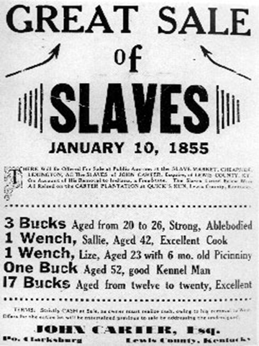

**E7.** Evaluate the usefulness of Source D as evidence of how slaves were sold. (You may want to comment on who wrote it, when they wrote it, why they wrote it, what they say or what has been missed out)

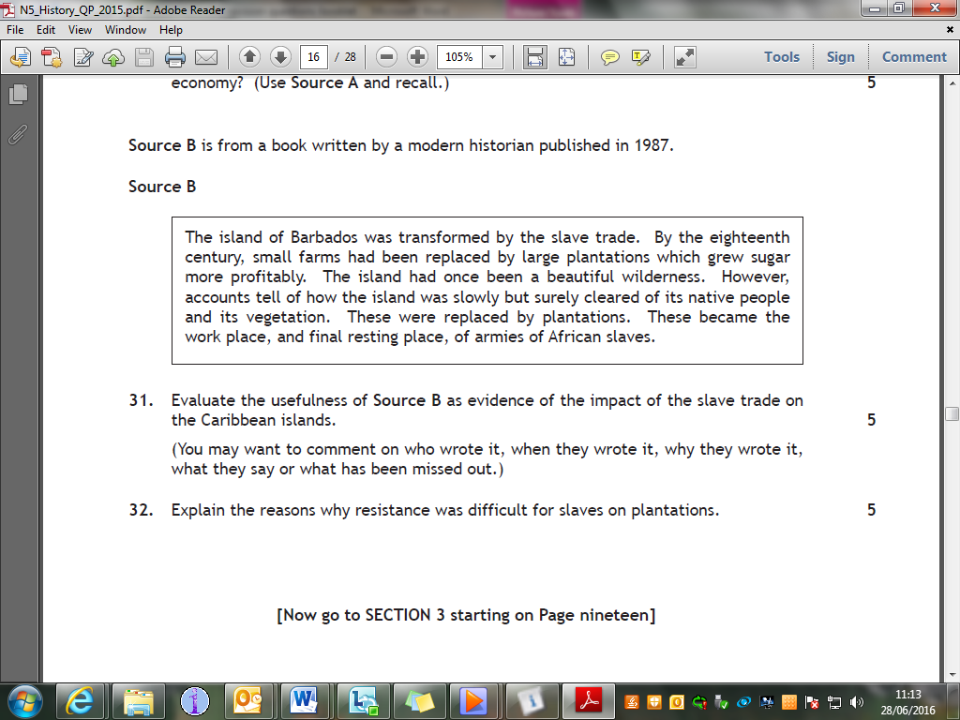

**E8.**

**Migration and Empire**

**Source A** is a picture depicting an Irish family taken from a British magazine in the 1840s



**E8.** Evaluate the usefulness of Source A as evidence of why so many people left Ireland in the 1800s. (You may want to comment on who wrote it, when they wrote it, why they wrote it, what they say or what has been missed out)

**Source B** was written by a visitor to Skye in 1865.

When the landlord appeared the tenants all greeted him respectfully. One by one the people approached him to let him know what they needed in order to emigrate. One man had not yet saved up his passage-money and required a loan; a woman desired a pair of blankets; an old man wished the landlord to buy his cow for a fair price. For each the way to Canada was eased.

**E9.** Evaluate the usefulness of Source B as evidence of Highland emigration in the 1800s? (You may want to comment on who wrote it, when they wrote it, why they wrote it, what they say or what has been missed out)

**Source C** is evidence given to a government inquiry in 1836 by a Catholic priest in Aberdeen.

The number of cotton and linen factories in Aberdeen has continued to grow since the Irish people were encouraged to come to us. Finding work is easy and fairly good wages are offered to them in these factories. A considerable number of Irish people have come to the city and have brought their families with them.

**E10.** How useful is Source C as evidence of reasons that many Irish people moved to Scotland after 1830? (You may want to comment on who wrote it, when they wrote it, why they wrote it, what they say or what has been missed out)

**Source D** is from a statement by a cotton manufacturer in Glasgow in 1836.

When the Irish first come over here, both the parents and the children are generally very decent and respectable. After they have been here some time their behaviour deteriorates. The change comes about by mixing with the lowest dregs of our Scottish working population.

**E11.** Evaluate the usefulness of Source D as evidence of Scottish attitudes to Irish immigration in the 1830s. (You may want to comment on who wrote it, when they wrote it, why they wrote it, what they say or what has been missed out)

**Source E** is a statement by Reverend William Bell in 1819 about the quality of water on board a ship travelling from Edinburgh to Canada.

Our water has for some time past been very bad. When it was drawn out of the casks it was no cleaner than that of a dirty kennel after a shower of rain, so that its appearance alone was sufficient to sicken one. Buts its dirty appearance was not its worst quality. It had such a rancid smell that to be in the same neighbourhood was enough to turn one's stomach.

**E12.** Evaluate the usefulness of Source E as evidence of conditions on board the emigrant ships that travelled from Scotland to the Americas. (You may want to comment on who wrote it, when they wrote it, why they wrote it, what they say or what has been missed out)

**Comparison questions**

**The Cold War**

Source A

Under Fidel Castro, Cuba was a proud example of a Communist country and was a role model to other countries. Khrushchev had the idea of installing a small number of nuclear missiles on Cuba without letting the USA know until it was too late to stop them. Khrushchev said they only wanted to keep the Americans from invading Cuba. He stated they had no desire to start a war.

Source B

To the American government, placing missiles on Cuba was a warlike act by the Soviets. They believed that the Soviet Union intended to supply a large number of powerful nuclear weapons. Spy photographs proved the offensive purpose of the missiles which were pointed directly at major American cities. It was estimated that within a few minutes of them being fired, 80 million Americans would be dead.

**F1.** Compare the views in Sources A and B about the Soviet Union’s actions during the Cuban Missile Crisis. (Compare the sources overall and/or in detail)

Source C

The alliance against a common enemy during the Second World War broke down almost as soon as the war ended and was replaced by a climate of suspicion. Soviet and American leaders held opposing ideological views and attempted to spread their beliefs to other countries. Tensions continued to grow over the next few years. America’s decision to develop and use the atomic bomb against the Japanese without consulting the Soviets placed further strain on relations.

Source D

As soon as the war ended the Soviet Union and the Americans developed open hostility towards each other. The meetings at Yalta and Potsdam did little to improve relations. The new President Truman and Stalin seemed hostile to one another and this emphasised their ideological divisions. The tension at Potsdam was increased by America’s use of the atomic bomb against Japan.

**F2.** Compare the views in Sources C and D about the reasons that the Cold War broke out between the Soviet Union and USA.(Compare the sources overall and/or in detail)

Source E

The Vietcong, or “Charlie” as the Americans called them, were the locally born guerrilla fighters of South Vietnam. The Vietcong consisted of three groups: units of regular soldiers, provincial forces, and part-time guerrillas. The Vietcong generally avoided large scale attacks on the enemy but continually harassed their troops and installations causing heavy American casualties. They travelled light, carrying basic weapons and few supplies.

Source F

Our first real battle was in the Michelin Rubber Plantation. Thousands of Vietcong launched wave after wave of attacks on our camp. But they had all kinds of Chinese and Russian weapons, such as flamethrowers and rocket launchers. Eventually we counter-attacked and pushed them back. Fortunately, we only lost around seven guys. The Vietcong body count was reported to have been 800, but I thought it was more.

**F3.** Compare the views in Sources E and F about Vietcong tactics. (Compare the sources overall and/or in detail)

Source G

To halt this build up, a strict quarantine of all offensive military equipment being shipped to Cuba is being introduced. All ships of any kind bound for Cuba from whatever nation or port will, if found to contain cargoes of offensive weapons, be turned back. We are not at this time, however, denying the necessities of life as the Soviets attempted to do in their Berlin blockade of 1948.

Source H

You, Mr President, are not declaring quarantine, but rather an ultimatum, and you are threatening that if we do not obey your orders, you will use force to turn back the ships. Think about what you are saying! And you want to persuade me to agree to this! What does it mean to agree to these demands? It would mean for us to conduct our relations with other countries not by reason, but by yielding to tyranny. You are not appealing to reason; you want to intimidate us.

**F4.** Compare the views in Sources G and H about the Cuban Missile Crisis.(Compare the sources overall and/or in detail)

**The Atlantic Slave Trade**

Source A

There were many reasons it took so long to abolish the slave trade. One reason was that the slave trade had many powerful supporters. Plantation owners and merchants in British ports which relied on the slave trade were well organised and had political influence. They had enough wealth to bribe MPs to support them. They also had the support of King George III. Many people believed that the trade had helped them to make Britain wealthy and prosperous.

Source B

The Abolitionists faced powerful opposition. The plantation owners allied themselves with important groups to promote the case for slavery and the slave trade. Their case seemed overwhelming. Dozens of British ports and surrounding areas relied on the slave trade. British consumers had become addicted to the products of the slave trade, most notably sugar. The Atlantic slave trade represented a large amount of British trade and seemed vital to the continuing prosperity of Britain and the Caribbean Islands.

**F5.** Compare the views in Sources A and B about the reasons that the slave trade continued in Britain throughout the 1700s. (Compare the sources overall and/or in detail)

Source C

The ships which had arrived on the African coast from Europe landed armed raiders who attacked African villages and seized as many men, women and children as possible. As soon as they saw a ship the Africans left their villages and took to the forests to hide. Another way Europeans obtained slaves was simply to buy them from their African masters. As the trade increased, Europeans built forts on the coast and established factories to hold captured slaves.

Source D

The slave trade across the Atlantic Ocean changed the whole course of African history. The kings and chiefs of the African tribes became trading partners with European merchants. They swapped their people for European goods such as horses, guns and alcohol. As the demand for slaves grew, raiding and kidnapping spread terror deep into Africa. Frightened villagers, trying to escape the raiders, moved into remote areas which often had poor soil and produced few crops.

**F6.** Compare the views in Sources C and D about the effect of slavery on Africa. (Compare the sources overall and/or in detail)

Source E

Slaves were treated in most cases like cattle. A man went about the country buying up slaves and he was called a “speculator”. Then he would sell them to the highest bidder. Oh! It was pitiful to see children taken from their mothers’ breasts, mothers sold, husbands sold to a different owner than their wives. One woman had a baby and he wouldn’t buy the baby.

Source F

The slave master made us hold up our heads while customers felt our hands and arms and looked at our teeth, precisely as someone examines a horse which he is about to purchase. All the time the auction was going on one mother was crying aloud. She begged the man not to buy her son unless he also bought her; but the boy was sold on his own to the man who offered the most money.

**F7.** Compare the views in Sources E and F about what happened during slave auctions. (Compare the sources overall and/or in detail)

Source G

Nowhere in history have a people experienced such a terrible ordeal as Africans during the Atlantic slave trade. Over nearly four centuries of the trade, millions of healthy men, women and children were savagely torn from their homeland, herded into ships, and dispersed all over the so called New World. Although there is no way to work out exactly how many people perished, it has been estimated that about 10 million Africans survived the Middle Passage.

Source H

The Atlantic slave trade spelled disaster for Africa and its peoples. For four hundred years, millions of the healthiest young people of the region were stolen from their homeland. No-one is sure exactly how many were sold into slavery but probably about 11 million African people arrived in the New World between 1450 and 1850. Add to that the number who died in war or on the journey and you can begin to see the devastating effect on families at that time.

**F8.** Compare the views in Sources G and H about the effects of the slave trade on Africa and its peoples. (Compare the sources overall and/or in detail)

**Migration and Empire**

Source A

I feel that everything the agent told me about this country has turned out to be false and I dearly wish to return home. I am very much dissatisfied with the poor quality of the land which will never be of much use. The nearest town is two days’ journey away and my daughter and I suffer a great deal from loneliness.

Source B

I have already prepared 14 acres of good land and, if I am spared, I shall have 40 ready next year. I got a splendid horse and a good cow and a calf, plenty milk and butter, plenty to eat of everything. Our wee community is doing well and our fellow immigrants have already built a church and a school-house. There is not a better place in the whole world.

**F9.** Compare the views in Sources A and B about the experiences of Scottish emigrants. (Compare the sources overall and/or in detail)

Source C

Many Lithuanians were treated badly, they were frequently verbally abused in the street. Scots had the notion that the poor of Eastern Europe were swarming upon their shores. They were often mistaken as “Poles” and some were violently attacked. They were accused of dragging down wages and breaking strikes.

Source D

There were many reports about them being “Strike- breakers” and cheap labour. Scots were worried about the arrival of so many very poor Lithuanians. In 1926 one Auchinleck woman was arrested for throwing stones at Lithuanian men. The Glasgow Trades Council declared the Lithuanians in Glengarnock as “an evil”.

**F10.** Compare the views in Sources C and D about Scottish attitudes towards Lithuanian immigrants. (Compare the sources overall and/or in detail)

Source E

Irish immigrants tended to concentrate in particular areas because they were disliked by the native Scots. It was natural that the immigrants should live together but the determination to stick to their own culture was looked upon with suspicion. There were accusations that they did not wish to become “new Scots”. In addition, the Irish did not receive much credit for their contribution to the Scottish economy.

Source F

There was a reluctance to admit that Irish workers were essential to the development of industry in Scotland even though they were to be found wherever work needed doing. Many Scots criticised immigrants for keeping to their native language and religion. It became clear that there was a great deal of resentment against the immigrants in Scotland.

**F11.** Compare the views in Sources E and F about Scottish views on Irish immigration. (Compare the sources overall and/or in detail)

Source G

Irish immigration continued steadily until the 1840s. The Irish potato famine of the mid 1840s however led to a sharp increase in this immigration. It led to great poverty and some landlords evicted those who could not pay their rent. Transport costs were cheap, and wages in the west of Scotland continued to be higher than those in Ireland.

Source H

In the mid and late 1840s the potato crops in Ireland were destroyed by blight, which caused the death of many people and led many others to leave. Many landlords used the crisis to take away people’s homes. The very low wages paid in Ireland meant that the higher wages on offer in Scotland were attractive. Irish people found it was not far to travel to Scotland and that plenty of ships travelled the route, so the cost was cheap. Travelling conditions were miserable.

**F12.** Compare the views in Sources G and H about reasons for Irish immigration. (Compare the sources overall and/or in detail)

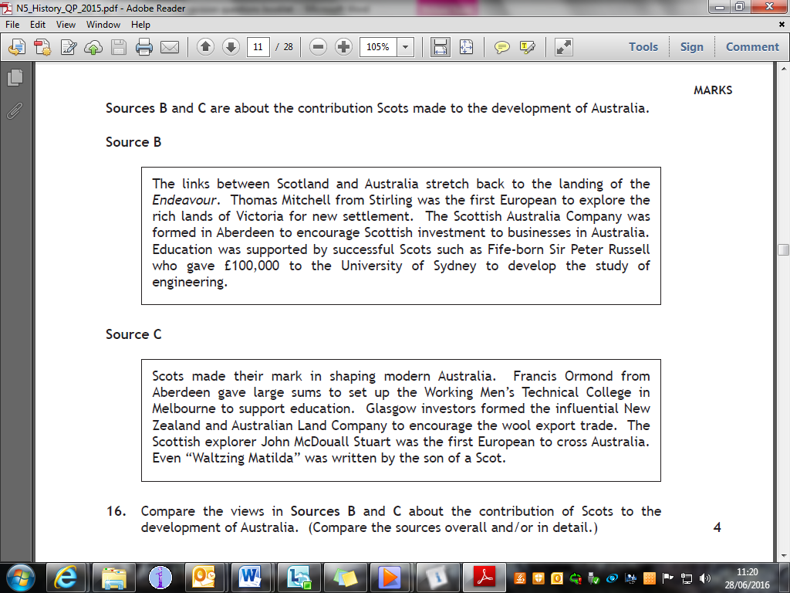

**F13.**

**Need to know**

**The Cold War**

|  |  |
| --- | --- |
| **Reasons for the emergence of the Cold War, up to 1955**  **Flashpoints — Hungary, Berlin, and Cuba**    **The Vietnam War**  **Changing relations between the superpowers, 1968–89** | * NATO and the Warsaw Pact * Political beliefs * Military rivalry and mutual suspicion * Effects of the development of nuclear weapons on relationships. * Korean War. * Hungarian revolution, 1956: reasons for revolution; Soviet response; wider significance. * Berlin: reasons for importance, building of the Berlin Wall, impact on international relations. * Cuba: Castro’s victory in Cuba. Reasons for development of Cuban Crisis: The Monroe Doctrine and US Foreign Policy, domestic pressures on Kennedy, domestic pressures on Khrushchev. Events of the crisis, impact on international relations.   -Reasons for United States involvement  -Reasons for failure to defeat the Vietcong  - Changing views on the war in the United States  - Impact on international relations.   * Attempts at détente * Reasons for changing attitudes between the USA and the USSR * The danger of Mutually Assured Destruction * Economic cost of arms race * American desire to get out of Vietnam * SALT and other agreements * Glasnost and Perestroika. |

**The Atlantic Slave Trade**

|  |  |
| --- | --- |
| **The Triangular Trade**  **Britain and the Caribbean**  **The captive’s experience and slave resistance**  **The abolitionist campaigns** | * The organisation and nature of the slave trade * Its effects on British ports, eg Liverpool, * Its effects on African societies e.g. the Ashanti tribe and on West Indian plantations. * Slave ‘factories’ on the African coast; * The economics and conditions of the ‘Middle Passage’. * The importance of tropical crops such as sugar * The influence of the British in the Caribbean * The impact of the Caribbean trade on the British economy (eg banking, ship-building, textiles) * The negative impact of the slave trade on the development of the Caribbean islands. * Living and working conditions on the plantations * Discipline * Other forms of slave labour on the Caribbean islands * Resistance on the plantations * Fear of revolt. * Origins of the abolitionist movement and its increased support outside and within Parliament. * Role of Wilberforce. * Arguments of the abolitionists: Christian, humanitarian, economic. * Methods of the abolitionists: meetings, evidence (eg Clarkson; first-hand accounts by slavers, publicity). * Attitudes and evidence of slaves and former slaves (eg Equiano). * Resistance to the trade by slaves. * Arguments for the slave trade: planters, MPs, cities; effect of the French Revolution. * The debate over reasons for the eventual success of the abolition campaign * public opinion * Parliamentary debate * economic circumstances. |

**Migration and Empire**

|  |  |
| --- | --- |
| **Immigration to Scotland, 1830s–1939**  **Experience of immigrants to Scotland, 1830s–1939**  **Scottish emigration, 1830s–1939**  **Experience of Scots abroad, 1830s–1939** | * Reasons for immigration of different groups * Patterns of settlement including Irish, Lithuanians, Jews and Italians * impact of the Empire on Scotland, including industry and commerce. * The experiences of the migrants — living conditions, employment. * Religious and cultural forces binding the Irish community in Scotland * Relations between immigrants and Scots * The economic, social and political impact of immigration. * Reasons for emigration: poverty; the Highland Clearances; missionary work; * Effectiveness of emigration societies and government schemes * The attraction of new lands (eg economic opportunity and cheap land). * Areas to which Scots emigrated (eg India, North America, Australia and New Zeland) * The role of Scots migrants in the development of the ‘New World’ (e.g. agriculture, manufacture, engineering and mining; education; finance; politics) * The contribution of individual Scots to their new countries (eg Andrew Carnegie, John Muir, Andrew Fisher). |

**Revision ideas**

Revision can be difficult. Here are 18 ideas which might help you to liven up revision and make you remember. Find out which ideas suits you best.

|  |  |
| --- | --- |
| **Study timetable**  Create a timetable of what you will study and when; build in rest periods too. | **‘Journey’**  Imagine a topic like a journey; what’s the first step, second step and so on. |
| **Flash cards**  Summarise each topic on a small card you can carry with you and use for last minute revision | **Write a song**  Add some key words to your favourite tune or song; see if you can then replay it in your head to remind you |
| **Record/listen to yourself**  Record yourself reading notes; listen to it when sleeping, out walking or at the gym | **Making a PowerPoint**  Make PowerPoint presentations about key topics which you can then revise |
| **P-E-E-L notes**  Practise writing PEEL paragraphs on different topics; use highlighters too to check you have included each section. | **Mnemonics**  Remember the first letters from words or phrases **e.g. ROY G. BIV** (red, orange, yellow, green, blue, indigo, violet) |
| **Writing over and over**  Write the same key information over and over until it sticks in your head. | **Paper/notes around your house**  Leave notes in your room, on the fridge or elsewhere to teach you as you go |
| **Past Paper questions**  Practise Past Paper questions. You will find them in this book or on the SQA website. Your teacher can mark them. | **Playing Card revision**  Write your own playing cards **e.g.** question/ answer on different sides. Then test yourself or a friend. |
| **Reading**  Read your original notes or new notes you’ve made; maybe on the school bus? | **Link to objects**  Link key topics to objects in your room to help you visualise an answer |
| **Telling someone else**  Tell someone what you know about a topic; ask them to question you too | **Mind maps**  Write mind maps about key topics; it’s easier than remembering whole essays |
| **Study partners**  Work with a partner; share notes and test yourself. But don’t get distracted! | **Timed questions**  Give yourself a short fixed time to write everything you know about a topic. |

**Internet resources/Apps**

**BBC Bitesize History**

(There is also an app for this you can use on your phone)

<http://www.bbc.co.uk/education/subjects/z2phvcw>

**Mr Marr`s History**

<https://mrmarrhistory.wordpress.com/national-45/>

**Previous Exam Papers and Answers**

<http://www.sqa.org.uk/pastpapers/findpastpaper.htm?subject=History&level=N5>